### 

### To Investigate effective ways to improve hospital/care-home nurse coordination with the use of a web application.

### Final Year General Computing Project

***A Report submitted in partial fulfilment of the regulations governing the award of Degree of BSc (Honours) Computer Science with Web Development at the University of Northumbria at Newcastle.***

Jake Southward : W15024065

Supervisor: Yilun Shang

Second marker: Kamlesh Mistry

1. Declaration of Authorship

**DECLARATIONS**

I declare the following:

(1) that the material contained in this dissertation is the end result of my own work and that due acknowledgement has been given in the bibliography and references to ALL sources be they printed, electronic or personal.

(2) the Word Count of this Dissertation is ...................................

(3) that unless this dissertation has been confirmed as confidential, I agree to an entire electronic copy or sections of the dissertation to being placed on the eLearning Portal (Blackboard), if deemed appropriate, to allow future students the opportunity to see examples of past dissertations. I understand that if displayed on eLearning Portal it would be made available for no longer than five years and that students would be able to print off copies or download.

(4) I agree to my dissertation being submitted to a plagiarism detection service, where it will be stored in a database and compared against work submitted from this or any other School or from other institutions using the service. In the event of the service detecting a high degree of similarity between content within the service this will be reported back to my supervisor and second marker, who may decide to undertake further investigation that may ultimately lead to disciplinary actions, should instances of plagiarism be detected.

(5) I have read the Northumbria University/Engineering and Environment Policy Statement on Ethics in Research and Consultancy and I confirm that ethical issues have been considered, evaluated, and appropriately addressed in this research.



SIGNED:

1. Acknowledgements

I would like to thank the following for their contribution to the production of this dissertation.

Firstly I would like to thank my supervisor Yilun Shang, for support and feedback on my project. A thank you to everybody that participated in my questionnaire, providing valuable information. Finally I would like to thank my housemates and family for continuous support throughout the project.

1. Abstract

This project describes the research and development of a multi-platform web application for use in hospitals and care homes. Filling a potential gap in patient staff communication. The web application aims to provide patients and residents with a facility to request help from nurses. The application also aims to provide data analysis for blood glucose level of patients and residents. Staff users are provided with the capability to prioritize their precious time when responding to requests, and in the event of an emergency request help from all staff members. The main focus of the application is to streamline and support the nurses in their roles. Which is why the application is named Nightingale, after the founder of modern nursing, Florence nightingale. Human computer interaction HCI is an increasingly important field of study as adoption trends for the elderly and disabled grow. In part due to the awareness of application designers to the accessibility needs of users. Appropriate literature has been analysed throughout, building an appropriate solution that fits the challenging needs of its target user demographics.

Research has been performed to aid the design of features and closely match the needs of nurses and patients in balance. The design and development of the software solution has been documented along with the HCI considerations throughout this project. The appropriateness of HCI methods are analysed closely in relation to the project.

1. Table of Contents

a) Declaration of Authorship 2

b) Acknowledgements 3

c) Abstract 4

d) Table of Contents 5

1. Introduction 6

2. Analysis 8

2.1. The Problem 8

2.2. Literature Review 11

2.3. Software Implementation 14

2.4. Survey Design and Considerations 15

2.5. Survey Results 18

3. Synthesis 20

3.1. Design 20

3.2. Implementation 33

3.3. Cloud Server Implementation 43

3.4. Database Security 43

3.5. Coding Standards 43

4. Testing 44

5. Evaluations and Conclusions 45

6. References 46

7. Appendices 49

a) Terms of Reference 49

b) Design Documentation 60

*c)* Diagrams 63

d) Code snippets 70

e) Test Plan and Results 70

f) Gannt Charts 73

g) Meeting Documentation / eLogbook 74

1. Introduction

**Project Background**

By examining the aims and objectives of this project a more complete understanding of the project can be achieved.

**Aims of the project**

*“Investigate if hospital/care home alert systems could be improved with the use of a web application in line with smartphone adoption trends.”* This aim addresses the investigative portion of this project, making it necessary to discover how or if the goals of the project could be realised. This will be addressed with the use of extensive research into the target area, as well as a thoroughly designed web-based application.

*“Develop an advanced web service/app to help staff prioritise patient requests in unique hospital and care home settings.”* The project will not only investigate potential solutions, it will aim to design, develop, and test a system that addresses the potential problems (see *Potential problems chapter 2.1*).

**Objectives of the project**

*“Perform a literature review of HCI and accessibility for the elderly and disabled, to determine the unique considerations for each group.”* The research conducted will provide the basis for the design of the web application, so it is very important for the project. Key areas will be tackled, such as: HCI methodologies, Heuristic evaluation schemes, the target demographics and their specific needs, e-mental health and medical assistive technology will also be covered.

*“To research relevant information on both staff and patient users to ensure that the application is fit for purpose.“* Research into hospital and care home staff will address this objective. Its importance will be realised in the designing of the functionality within the system. Understanding both may give insight into potential functionality or goals for the project that were overlooked before research began.

*“Gather information from people with experience in care home or hospital environments using a questionnaire. And ask questions about their workflow and current systems in place for patients to alert a member of staff.“* A method for gathering data on the functioning of a hospital or care home will be to ask nurses or staff that have experience within a care home or hospital environment to fill in a questionnaire. This data will determine the necessity of potential application functionality and yield a more accurate representation of the problems associated.

*“Produce high quality design documentation to aid the development of my application. Including wireframes and photoshop mock-ups, as well as technical diagrams to show the movement of data and relationships in the database.”* Aided by the research into staff and patient users and HCI considerations the design documentation will group the concepts and data into a logical plan going forward. Some of the deliverables include: wireframing, use case diagrams, data flow and heuristic evaluation of the GUI designs.

*“Develop an accessible patient call system application interface that is fit for my user demographic. I will use latest trends in design to achieve a visually appealing look.”* The interface design will be of great importance as it will be the only way a user will interact with the system. For many of the user demographics this stage has vital importance for usability and accessibility.

*“Implement a MSQL database for storing data needed by the application.”* The database will be at the core of the development as all data will have to be secure and accessible to the rest of the system, great care will be taken to assure this.

*“Securely connect the front end and database to display relevant information from the database in real time.“* Again this will be realised through meticulous design of components and acknowledgement of security concerns throughout development. AJAX will be utilized with PHP to populate the information to the page in real time.

*“Generate a list of tasks for volunteer test users to perform, testing normal and abnormal use of the application, to ensure it is fit for purpose.”* User testing is in important task in the development of a functioning system. The creation of a comprehensive list of tasks will improve the testing and ensure all of the features are working as intended and bug free.

*“To produce a test plan when performing meticulous product testing, and user testing of my application.”* The user testing will reveal how effective the design of the application for specific demographics has been. By recording the average time to complete tasks and the comprehension when using the application insightful data into how the application can be improved will be attained.

*“Evaluate the final application to determine how it meets my brief, taking into consideration all research and requirements.”* A number of other objectives will be helpful in the evaluation process, for example the user testing will provide a more impartial analysis of how the application meets its brief.

**Project Stages**

The initial stage will be the analysis chapter. Beginning with ’the problem’, which will involve describing the problem that the project aims to address covering the key points for consideration. Next will be the literature review. The literature review section will review relevant literature relating to HCI for important user demographics, and any other critical research. ‘Software implementation’ will be a research section on the software implementation, covering types of system architecture and the pros and cons of each. To finish off the analysis phase will be a research questionnaire for health care workers and an analysis of the results.

After the analysis phase will be the synthesis. This chapter will firstly address the design of the software solution, covering interface design, language choices and database design. After this stage, the software solution will be developed. This will be performed alongside of the implementation section, which will aim to document interesting or challenging problems that are solved in the development phase. The solution will be nearing an end point in development by this time. At this point it will be time to configure and deploy the cloud solution that the software solution will reside. Documenting again problems and solutions that are encountered. To conclude this chapter the database security will be fine tuned to ensure the solution is of a high standard, the steps will be recorded.

The final chapters will be for software solution testing and an evaluation. The testing phase will involve a number of testing tables and user testing to determine if the application is complete. The evaluation will address the outcome of the whole project, stating future direction and how each stage of the project contributed to the project aims and objectives.

1. Analysis

The analysis will comprise of three chapters: identifying the problem, which will address the issues concerns that will arise throughout the project and the problems the software solution will have to address. A literature review will be performed to understand necessary aspects of the scope of the project. Finally the software implementation section will cover research into scalability specific to the software implementation and justification for the project.

* 1. The Problem

The project as covered in the aims section of the introduction will have to overcome a number of issues, ranging from universal usability, technology, and consideration of concerns with current healthcare. This section will provide a clear perspective of the problems this project will strive to overcome.

**Universal Usability**

There are a number of demographics to consider. The vast majority will need no further accommodation to use the application, such as young healthy adults. However there are many that may need additional or specialised help when the problem is investigated. In particular: Elderly, disabled and non-Native speakers will likely require additional consideration.

Disabled users may require additional assistance. A disability is described as a physical or mental problem which interferes with the function of an individual’s participation in an activity. Disability can affect the experiences of an individual greatly. The experiences often depend on a number of aspects: Health conditions as well as personal and environmental Factors. Disability can be analysed in a number of ways; however the purpose of analysis disability will be separated into four categories: Visual, Auditory, Motor impairment and Cognitive impairment. (World Health Organization, 2011) These have been selected as the primary considerations.

**Visual disabilities**

Blindness concerns the loss or partial loss of sight. Screen readers are the only means of allowing a blind person to see what is on the screen. However, this brings limitations such as comprehension of images used. To combat this issue alternate text should be provided allowing comprehension of the page to the user.

Low vision describes the partial loss or reduced capabilities of eyesight. Often affecting reading and colour differentiation. To accommodate for this large text should be used in combination with highly contrasting colours.

Colour blindness can cause problems distinguishing or seeing colours. The most popular being red-green colour blindness, preventing people from differentiating between them. To adapt for this high contrast modes or black and white modes can be used in applications, although not widely considered.

**Auditory disabilities**

Deafness can affect people in a number of ways. From minor such as tinnitus, to full deafness whereby the ear is not functional. Speech can be hard to distinguish therefore visual aids are essential. Such as text on screen or subtitles.

**Motor impairment**

Can be from the mild, slowing the behaviour of a person, to severe. Potentially an Inability to move at all. Many aids exist to make activities more accessible, for instance voice recognition can allow the control of a system by means of the voice alone. Text entry aids also work to make keystrokes more concise for the writing of words or sentences with a single key press.

**Cognitive impairment**

Affecting the memory concentrating and learning. The symptoms include reasoning skills, perception, judgement, and memory. People with dementia for example may struggle to concentrate on tasks and show significant loss in short/long-term memory. To aid users with minimal cognitive impairment image aids such as icons can be used, as well as clear on-screen instructions that serve to remind the user.

The elderly, although not exclusively considered disabled, suffer a range of degenerative impacts associated with aging. Eyesight and hearing can be affected greatly. Colour processing tends to decline with age, at 60-70 colour discrimination drops to 76 percent and between 80-90 it further drops to 56 percent (Congdon, N, 2004). Vision degeneration also affects the ability to focus on static and moving objects of varying distances. This can become a huge challenge for the elderly particularly when paired with hearing loss. As people age the range of frequencies that can be heard diminish, making it much harder to perceive sounds and speech effectively. A number of aids are available for the degenerative effects of aging; hearing aids to amplify the sounds, glasses to help with focusing of distant or close objects. However the reduction of colour vision cannot be improved with personal aids, therefore consideration must be made to use highly contrasting colours for improved readability.

**Language**

Another consideration is that of non-native English speakers, according to 2011 census data, 864,000 people in England and Wales reported speaking little or no English (Office for National Statistics, 2020) . This demographic cannot be ignored, it would be beneficial to accommodate their needs with the use of language options.

Although not all issues can be addressed throughout this project select issues can be aided (see design section). Any attempt to combat issues within public environments must recognise these considerations as the demographics discussed make up a large quantity of hospital and care home patients. Failure to consider these groups could be viewed as discriminating against these groups.

**Problems with HCI Heuristic evaluation**

Developing applications with HCI in mind there is a huge number of differing ‘rules’ to follow to generate inclusive and usable software. However HCI literature often struggles to bridge the gap between research and practice effectively. This problem occurs as the researchers are not aware of the context that the literature will be used. For example it may be used in sales, or marketing or for use in hospital software. This can make it difficult to present guidelines for a specific project, and successfully find guidance on specific HCI needs. These issues will be further addressed in the literature review (section 2.2) to try and discover the best rules to follow in the development of this specific project.

**Data Visualization**

The software solution will have to present data in a clear way which leads to the problem of how data should be presented. The principles of data visualisation must be understood to allow accurate data presentation as well as being robust enough for medical use.

**Concerns with current healthcare**

Understaffing and underfunding, patient wait times, staff availability. These are just some of the problems associated with medical settings. To illustrate the point a study found that nurses spend an average of only 31% of their time with patients, whilst the rest is spent performing administrative duties (Hendrickson, Doddato and Kovner, 1990). Since 1997 the number of nurses leaving the profession has outstripped the number of entrants (B Finlayson, 2002). Leaving less nurses to handle more patients, resulting in less time spent with patients. The issues seem to stem from underfunding however there may be more that can be done to simplify nursing time management so that they can spend more time with patients each day.

Staff harassment is a major problem in hospitals and care homes. A study delivered a questionnaire to 281 nurses and 206 nursing students (80% women), they found Ninety percent of participants had experienced at least one type of sexual harassment (Bronner G, Peretz, C. 2003). This is an area of interest that should be addressed in the final software solution.

* 1. Literature Review

This literature review will look into the current research into general HCI considerations and methodologies as well as more specialised HCI aspects in relation to target demographics of the application. Each of the HCI concepts will be explored and the value for use in the app considered.

**HCI Methodologies**

Many HCI researchers have proposed rules to follow when building a system with human interaction, such as: prevention of errors, Universal usability, and simplistic design of interaction. These principles are based on HCI research and give system designers an array of useful heuristics to prevent user interface errors and usability problems. Many heuristic tables exist with varying rules/attributes mirroring human psychology and intuition (Dix, 2003); *Nielsen’s ten usability heuristics* (Nielsen, 1994) is a common methodology and *Schneiderman’s golden rules* (Shneiderman, 1998) are often cited. However each of the tables have shortcomings and advantages associated, discussed below.

Nielsen’s ten usability heuristics is particularly useful due to its high-level approach. It particularly stands out as it reinforces the significance of using documentation and help for the user as they navigate the system. Help guides and documentation can be particularly useful for elderly users, elderly users that have access to visual training can even result in better or comparable results to young users (Mykityshyn, Fisk and Rogers, 2002) This should not be neglected when considering this approach.

Schneiderman’s golden rules present a shorter list of underlying design principles than other heuristic evaluation methods, making it more concise. This approach is considered to have an advantage over many methods as it considers the use of ‘dialogs’ to guide the user through the system. Schneiderman provides guidance in utilizing dialogs in the system design providing designers with the tools to make more useable systems. (Shneiderman, 1998) Where this differs from documentation or help is the use of the dialogs. Dialogs do not serve to supplement the content; it is the content of the system. For example, a button with a concise description of its function.

In *First Principles of Interface Design* (Tognazzini, 2003), Tognazzini Indicates 16 principles and claims they are “fundamental” in the design and implementations of systems. Tognazzini particularly addresses colour-blindness stating that secondary cues to convey the information are important when using colour to convey a message. An example of this would be a UK pedestrian crossing, the green man is also in a walking position as a fallback to those that may not perceive the green colour. However the 16 principles are lacking in description when it comes to implementation of these principles in a system.

To benefit from the many differing heuristic evaluation schemes a multiple heuristics evaluation table (MHET) has been created (Wheeler Atkinson, Bennett, Bahr and Walwanis Nelson, 2007). This combined approach takes the most common elements and creates a more inclusive list (see *figure 1 below*).

*Figure 1* – MHET Heuristic Scheme

|  |  |
| --- | --- |
| **MHET Heuristic** | **Description of Heuristic** |
| Software User Interaction | Providing the user with necessary information for interaction. Combining overlapping concepts: “Visibility of system status” (Nielsen, 1994), “Offer informative feedback and Design dialogs to yield closure” (Shneiderman, 1998). |
| Learnability | Training tools and learning aids within the system. Making the system easy and intuitive to learn. |
| Cognition Facilitation | Reducing the cognitive load on the user, combining multiple heuristics such as: “Recognition rather than recall” (Nielsen, 1994) and “reduce short term memory load“ (Shneiderman, 1998). |
| User Control & Flexibility | Creating software that responds flexibly to user actions. “flexibility and efficiency of use” (Nielsen, 1994). Shortcut keys, toolbar icons and other interaction controls. |
| System Real-World Match | Matching the system with the real world, elements such as shopping carts/baskets in a store for example. “match between system and the real world” (Nielsen, 1994). |
| Graphic Design | Defining the quality of design in a system through “Graphical integrity, Multifunctioning graphical elements, Colours and Increasing data comprehension, fitts’ law” (Tognazzini, 2003). |
| Navigation & Exiting | Concept of easy navigation within a system and intuitive reversal of accidental actions. “User control and freedom” (Nielsen, 1994) “Permit easy reversal of actions” (Shneiderman, 1998) “Explorable interfaces and visible navigation” (Tognazzini, 2003). |
| Consistency | Consistent terminology, GUI elements throughout the system. “Should not use multiple words to describe the same function” (Nielsen, 1994). |
| Defaults | Referring to placeholder or default content in input fields to prompt the user to set their own information. “Defaults should be easy to change or delete” (Tognazzini, 2003). |
| System-Software Interaction | How effectively the system can use and present the status of the use of resources on the computer. For example: “reasonable  speed of processing” or “Latency reduction” (Tognazzini, 2003) and “Visibility of system status” (Nielsen, 1994) such as loading screens and status of the process. |
| Help & Documentation | The importance of help files and documentation as well as on screen assistance or prompts without straining the user. (Nielsen, 1994) (Tognazzini, 2003). |
| Error Management | The ability to aid users in noticing, understanding and recovering from errors in the system (Nielsen, 1994) (Tognazzini, 2003) (Shneiderman, 1998). |

**Universal Usability in HCI**

Universal usability is a core aspect of medical assistive systems as the demographics that it caters for are often more challenging for some Heuristic evaluation schemes. The 12 MHET design heuristics (*figure 1.0)* provides an encompassing methodology for system HCI design. However it fails to cover universal usability and accessibility inclusively.

Simplistic interaction design is increasingly important for universal usability when the user demographics may be elderly or disabled. Simplicity is often hard to achieve as functionality cannot be compromised within the system, but an overwhelming number of options can lead to confusion. Ed Chi a computer science researcher at Google discovered that users tend to have a bias towards seeing what they want to see for a particular goal (Nielsen Norman Group. 2020). This phenomena is named “information scent”, this can be used to aid users on a simplified path through the system to the goal. By braking up a large list of functions into category pages and allowing navigation led by the information scent the user can more efficiently navigate without indecision or hesitation.

Bigger buttons are better. Fitts' Law included as one of the 16 principles in *First Principles of Interface Design* (Tognazzini, 2003) was published in 1954. Fitts’ law states that the time required to move to a target for example a button depends on the distance to the target. However, inversely relates to the size of the button. This means that larger target areas of interaction will speed up the comprehension and the smaller the target the longer it will take (Fitts, 1954). Although widely accepted in HCI and UI design it is often overlooked. Fitts law is a very important factor for the elderly due to common vision impairments in this demographic, further making it a necessity to use larger buttons.

**HCI and e‐health**

Online aids and applications are often used for collaborative care and treatment (Andersson, G. 2014). They are cost-effective, accessible, and are generally quite effective. However the design protocols in place for such e-health systems in relation to HCI could be seen as a grey area. One piece of research screened and analysed 30 research papers to understand how HCI was considered. They found very little about the design infrastructure available for mental health software (Neilsen, A. Wilson. 2019). Given the vulnerability of the demographic they urged future publication of e‐mental health interventions to include adequate design principles, so that that mental health nurses are able to critically analyse the suitability of these aids for patients.

Another Review on this topic concluded that “further research is needed to understand how and why specific design features may affect intervention outcome” (Morrison, 2012). The distinct lack of material associated with HCI practices with vulnerable patients leaves user experience designers guessing. Although more interdisciplinary collaboration with researchers from a wider field of study could result in a greater and deeper understanding of the requirements of e-health systems.

**Data Visualization**

The process of turning large amounts of raw data into valuable scientific graphics is without doubt invaluable. Many textbooks document the process of generating good statistical graphics. Tufte, (Tufte, 2001) created guidelines on visualising data that are still relevant today. There are key points to consider below.

Create the simplest graph that conveys the information want to convey (Tufte, 2001). This is in important point as overexposure to unnecessary data will abstract the data. The right balance of useful ordered data will aid in visualising, however not enough data will oversimplify, and relevance may be lost.

Graphical encoding type (Kelleher and Wagener, 2011). It is important to understand the types of encoding objects (points, lines, and bars) and their uses. Humans are able to quantify and analyse certain graph elements better when grouped with specific data sets. For example in this project it likely that data will be time-series based therefore a pie chart would be an obvious mistake. Although bar and line graphs could be utilized.

Select meaningful axis ranges (Tufte, 2001). Even if the correct data is being plotted using the correct axis, it is still possible to distort the data. For example, a time-series plot X axis should always have the relative difference in time absolute. Meaning with no warping for missing data or long time periods between data. This matches the actual relative difference in values without distorting the data. Y axis should display only relevant scale, so starting at 0 is not always necessary. Although in some uses a small percentage of overlap makes the data scale clearer.

Use of lines when connecting chronological data in time-series plots (Kelleher and Wagener, 2011). It is important to only use connecting lines on data where a sequential nature is implied. This includes chronological or time-series data. Connecting lines should not be used on data that can be separated into groups.

**Potential Solutions**

Medical assistive technology and e-health could benefit from further study, there are still many questions left unanswered. The widespread adoption of a more interdisciplinary strategy is necessary, whereby experimental studies would produce clinical evidence that an approach is favourable. Briefing document was produced (Pagliari C, 2007), with guidelines on how this can be achieved. Development of adaptive HCI concepts for elderly users would make the information more accessible for user experience designers that aim to design systems for use with the elderly.

* 1. Software Implementation

This section will aim to address software implementation methods, looking at different approaches and their application in the software solution this project aims to develop. Firstly looking at native and web-based architecture. Next, database and server configurations will be compared with consideration of the project goals. Summarizing with a breakdown of rationale of considered methods for the software solution this project aims to develop.

Comparison of native apps and web apps can be difficult as each has its place, and its own advantages and disadvantages associated.

Native applications as the name implies, describe applications developed for a specific operating system. Common systems include Google’s android (Native Java), Apple’s IOS (Native objective C) and less commonly Windows Phone (Native .NET). Each having native application support, and each with a different language. This can quickly become costly when developing a native application, as it could mean creating and maintaining a different app for each system that you support. Although many native applications harness the device capabilities, with hardware interaction, push notifications and waking phone from sleep. These features are essential for some application functionality. Much research (Jobe, 2013) has been performed on the effectiveness of native vs web-based applications. Native apps are seemed to be the best choice for hardware intensive functionality. (Apple Objective-C, 2020) (Android Developers, 2020) (.NET Windows Phone, 2020)

The use of web apps is becoming more widespread, Apple even released tooling for web apps in its Dashcode project (mobiForge, 2020). This method relies on one system for multiple device operating systems. Speed would historically be a drawback for this method, however incremental speed increases in JavaScript and browser capabilities move forward, closing the gap. This innovation is mostly driven by browser competition primarily between Google and Mozilla (Firefox Performance Dashboard, 2020). Web apps weaknesses lie in hardware control, for example while a device is on standby you cannot take location data. This only poses as an issue where system functionality is integral for the application. Web GL advances have seen more complex 3d visualisation come to the browser and this may play a role in future web app development.

The use of native apps on mobile devices has clear underlying advantages in certain applications. Where hardware use is essential (GPS tracking, Camera use) web apps can fall short in these areas. While web apps are better suited to business needs, use of forms and data logging. Web apps can be updated without the need to push out an update to the users, strengthening security or removing bugs more easily. Furthermore web apps require less cost in development due to their multi-platform capabilities. Therefore consideration must be taken to select the appropriate method for particular software needs.

**Development Rationale**

Both methods; native and web-based have been analysed for use it was easier to see that a web-based solution is more appropriate for this project. The key points that ensured this were the cross compatibility, maintainability and the web-based nature of the data being presented. Scalability was another important consideration as using LAMP based architecture could ensure future expansion if the bandwidth of users on the system became a problem.

* 1. Survey Design and Considerations

For this project it was important to support the research into the needs of nurses (in hospital and care home setting) with first-hand information from the nurses. A basic survey was designed to ask questions about workflow for a nurse with experience in a care home or medical setting as well as how viable the application proposed would be in each setting.

**Legal and Ethical Considerations**

Consent is a very important consideration when conducting a survey. The participant must be fully aware of how the survey will be used and how their personal information will be shared. Upon opening the survey link they will be presented with a page outlining the project goals and what the aim of the survey will be. At the end of the survey will be a checkbox to confirm consent. The consent checkbox will be titled “I have been briefed about this research project and its purpose and agree to participate, check box to consent”.

**Data protection**

The collection of data will aim to abide by the laws of data protection. The personal data will be processed fairly and lawfully, with disclosure to the participant of its intended use. The data will not be transferred outside of the European Economic Area in accordance with the data protection act (GOV.UK. 2020).

The data will be gathered through a secure online survey host, the data will be stored within the cloud (through a secure cloud storage provider) and access will only be granted to myself. Although the data is not particularly sensitive it will only be held for the duration of the research and when the assessment period is over the data will be removed from the cloud storage (permanently).

Carefully selected survey questions will minimise the amount of potentially sensitive information that is held, by collecting only relevant information (name and email). The data gathered in the survey that is shared via this project document will use only participant numbers not personally identifying information. The email address of the participant will be taken in case further contact is needed.

**Survey design**

The data collected will be a combination of qualitative and quantitative questions. The questions will be mostly opinion based as the opinion of the staff users will be the primary consideration. The questionnaire will be distributed electronically, this will enable participants to give their response quickly and easily. An electronic survey will also make the interpretation of data much easier as it will already be in a digital form. Below is the questionnaire questions and consent information as the participant will receive it (via electronic form).

*Medical workers survey*

|  |  |  |
| --- | --- | --- |
|  | ​  Hi,  For my dissertation I have chosen to investigate how medical / care home settings can use modern technology to aid the elderly and hospital patients. Primarily looking at call systems for staff to respond in a timely manner to an incident. As well as measures to alert other staff members of violence and harassment in the workplace. I intend to develop an application for mobile devices for medical workers and patients/ residents to improve the alert system.  The questions should only take 5-10 mins.  **Personal Information. Will not be shared with anybody else.**  Name:  Email address:   1. **Where is your primary workplace experience?**   Option A: Hospital  Option B: Care home/ assisted living  Other (please specify):   1. **Please briefly describe your day to day tasks at work.**   Text field   1. ​**How many patients/residents need help at the same time. ( an estimate )**   Number field   1. **How can a patient/resident request help from you when you are not with them?**   Text field   1. **If a patient/resident has requested help how are the staff notified of this request?**   Text field   1. **Age of staff working with patients/residents where you have had experience. (you may select multiple)**   Checkbox A: 16-24 Checkbox Checked  Checkbox B: 25-40Checkbox Checked  Checkbox C: 41-64Checkbox Checked  Checkbox D: 65+Checkbox Checked   1. **Patients/residents do not receive care fast enough.**   Scale: Strongly disagree , Disagree, Neutral, Agree, Strongly Agree   1. **There is not enough staff in hospitals and care homes that you have had experience.**   Scale: Strongly disagree, Disagree, Neutral, Agree, Strongly Agree   1. **Violence or harassment towards staff ​can be a problem in hospitals and care homes that​ you have had experience.**   Scale: Strongly disagree, Disagree, Neutral, Agree, Strongly Agree   1. **(Optional) Do you have any comments ​on the topics raised in this questionnaire?**   Text field  **Consent**  I have been briefed about this research project and its purpose and agree to participate*  Check box to consent Checkbox Checked   |  | | --- | | **Submit button** | |

* 1. Survey Results

Results were gathered and split into two main categories, the qualitative and the quantitative. The quantitative questions could be plotted into appropriate graphs and tables. Whereas the qualitative required brief summaries of the results to be interpreted.

**Quantitative**

The first aspect of the results that was analysed was the matrix questions (questions 7,8,9 seen in the previous chapter). The results from all 16 participants confirmed the research performed in the literature review and brough attention to the severity of the problems within health care roles.

*figure 1 – Matrix Results*

*figure 1* depicts the answers to the matrix questions with the Y axis showing the volume of participant responses. None of the participants disagreed with the statements regarding hospital and care home environments. 69% of nurses agreed that patients/residents do not receive care fast enough. From personal experience, 94% agreed that there is not enough staff in hospitals and care homes. 69% agreed that violence or harassment towards staff can be a problem in hospitals and care homes.

When responding to question 3 “How many patients/residents need help at the same time?”, the average amount of patients that need help at the same time was 15 and the highest response was “20+”.

*figure 2 – Proportion of Staff Ages*

Question 6 asked the age of staff working with patients/residents where they have had experience. The above pie chart (*figure 2*) shows that the most common age category was 22-40 years of age; closely followed by age category 41-64. Whereas, the 65+ option was the smallest group.

**Qualitative**

Question 2 enquired how staff spend their time at work, the participant responses contradicted the research in chapter 2.1. The participant responses showed that medical staff in hospitals spend most of their time responding to patient requests, and very little was mentioned about the administrative duties. In future questionnaires it would be beneficial to have a section on the administration duties of staff.

How patients can request help and how do nurses respond? This was asked in question 4 and 5. All of the responses included the use of a ‘buzzer’, ‘alarm’ or ‘call system. Some of the care home responses referenced a in house system with display in the corridors and an audible alarm sounding until responded to. The use of pagers and displays was also referenced. Although no specific systems were referenced many similar solutions could be found online.

**Project Considerations**

Regarding staff harassment in the workplace being prevalent it could be beneficial for a software solution to address this. An alert button for staff that need assistance when experiencing harassment could be build into a software solution. This could allow staff to alert all other staff members to an incident, to ensure appropriate response. It is not uncommon for staff members to deal with more than 20 patients/residents at the same time. Therefore a suitable solution would have to bear this in mind, allowing appropriate viewing of requests on this scale.

Any software solution must have its target demographics considered. The typical ages of staff were within a wide range (16-66+) therefore a solution should be designed appropriately for usability. Many hospitals and care homes have existing basic systems in place to request patient/resident assistance. Integration with current call systems would be beneficial, therefore a flexible solution should be considered.

1. Synthesis

The synthesis will consist of three chapters, Design, Implementation and Testing. And will discuss the work carried out to develop the application from a conceptual idea into a working tested outcome.

* 1. Design

The process of designing the application was achieved using a variety of methods. Initially the design was simplistic, and research was carried out to understand exactly the goals of the system and its place within the environment it would be used. The research identified the key considerations (see chapter 2.1) and from this a plan and concept of the program could be derived. Three key areas were considered: System design, Interface/user experience design and the vital features and functionality to be included in the application were derived. This chapter will break down the design elements in appendix (section B) and supplement the diagrams and designs.

**System Design**

The system needed to be compatible with any mobile device or computer to enable users to have unhindered access, without the need to install third party applications on the device. Updates can be added to a web application without the user having to update through the apple or google store. Additionally no approval from an app store is needed allowing fast multi-platform deployment. On the other hand native applications have the ability to harness the device capabilities such as camera and access to the photo gallery, which for some projects is a necessity. Considering the specific features planned a web browser-based application is the chosen route of development. The project would use latest methods such as a LAMP stack using apache, MySQL, and PHP as the primary languages for development.

Why LAMP? All the components in LAMP stack are open source software that is readily available and often free. The use of PHP and MySQL enables rapid error fixing and full access to the source with or without an abstraction layer. It is a reliable and scalable platform which could be important with a potential for large number of users on the system. Another potential option is a MEAN stack, comprising of mostly JavaScript based technologies (NodeJS, Agular). The primary reason for not choosing this is that native LAMP applications work well on older browsers and mobile devices, therefore this is a primary consideration.

**Interface / HCI design**

The design of the user experience is one of the underpinning considerations throughout the project. Interface design is another important element of the application as it has to assure that it is universally accessible, and anyone can use it intuitively. The elderly were considered in the design process extensively. To achieve these goals consideration of HCI heuristic design was another factor throughout the design process taking elements from a number of popular approaches such as; *Schneiderman’s golden rules* (Shneiderman, 1998), *Nielsen’s ten usability heuristics* (Nielsen, 1994) and utilizing greatly the *Multiple Heuristic Evaluation Table* or MHET (Wheeler Atkinson, Bennett, Bahr and Walwanis Nelson, 2007).

To aid consistency within the web application primarily one font with minimal style variations will be used, this will make the application more cohesive. The primary font chosen is a sans serif, modern and clean font named “Montserrat”. Often boasted on many top 10 lists on the internet as an exceptionally readable font (Medium, 2020). Font readability is a key consideration for the application as users will be of many demographics, meaning people of all ages primarily the elderly cannot be overlooked during design. For this reason font size will be considered throughout to aid people with low vision and to make links easier to click according to fitts’ law (fitts’ 1954). The only variation from the main font is the logo as it needed to stand out as the brand identity. The logo font has a more sophisticated and professional look but is still very readable.

*Calistoga Regular (Logo Font only)*

*Montserrat Bold (Heading and Paragraph text)*

*Montserrat regular (Some Paragraph text)*

The chosen colour styles were selected with universal usability in mind, similar to the use of motorway signs high contrast between the background and the text was utilised. The chosen colour palette is simple using only basic colours and gradients.

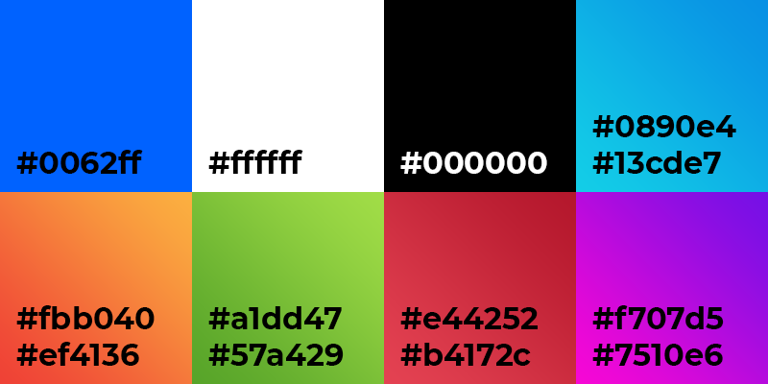

*figure 1 – colour scheme*

**MHET Considerations**

The 12 MHET elements from the “MHET heuristic scheme” (see section 2.2 *Figure 1*) were used to break the problem into manageable deliverables; allowing each to be considered throughout the design process.

*Software User Interaction:* This is important throughout the system for a number of reasons. Staff users using the system may have to find the relevant patient information quickly, so that they can respond to a request in a timely manner. They may also require easy access to the current status of requests within the system. Users should understand the status of their request e.g. has their request been received or accepted by a staff user. The system should allow both parties to be aware of the system status via clear on-screen dialogs.

*Learnability:* The system should be intuitive to all users at all levels. By taking inspiration from a number of popular applications it will have a familiar feel. A simplified design will ensure that a user can access all information from a low number of pages therefore increasing the learnability of the system.

*Cognition Facilitation:* The system will rely on intuitive labelling of buttons with the use of icons and unique colours so that the users and staff users can easily identify vital information based on “recognition rather than recall” (Nielsen, 1994). For example, the icons on the requests found on the staff dashboard (see *figure 1.7* Appendices) will have identifying colours and icons allowing the information to be recognisable at a glance. Requests that have been accepted will be easily accessible so that the staff user can revisit the information (room numbers, request info etc.), reducing cognitive burden. Not all information will be displayed on the immediate dashboard screen, the staff user will have to click on the request to view the full request.

*User Control & Flexibility:* User control will be considered throughout, therefore minimising the number of onscreen clicks. This will simplify the process, especially for staff users that are working within time restraints. Again the use of icons and descriptive buttons will aid user control effectively.

*System Real-World Match:* The system will be handing a real-world problem and must convey the real-world aspects successfully. This will be addressed on the user and staff ends of the system. When a user has requested assistance, they will be reassured that their request is being handled. For the staff user, the location of patients will be included to create a link to the real world that is very tangible, and requests will have semantic meaning cementing the idea of real-world impact.

*Graphic Design:* Quality designs will be created throughout ensuring readability of dialog and clarity of style. The elderly were considered extensively with this heuristic, font styles and sizing as well as the pressable surface of the button being large enough. This will ensure that the system is useable for all demographics aforementioned. Colours were another aspect of this heuristic as consideration of colour blindness and low vision were vital for the goals of the system.

*Navigation & Exiting:* The visibility of navigation elements is important on the dashboard pages and the active page should be recognised by the user/staff user. Again exiting is an important consideration, back buttons should be logical and visible where necessary. After an operation is confirmed, such as a staff user accepting a request, the operation should be reversible in case of human error. Undo buttons will be present after actions to ensure reversibility.

*Consistency:* Graphical user interfaces (GUI’s) will be designed to have consistency with not only general system trends but will have its own conventions. A house style for fonts, icons, logos, colours, and dialog will be coherent throughout providing an experience that will flow more fluidly for end users.

*Defaults:* Default content will be used for the login and registering of a user account. Utilising placeholder text in forms to instruct the user what information is necessary in each input field. E.g. a name input field may say “first name” and when the user clicks into the field, they can type the first name without deleting the placeholder text. Checkboxes may also be used with default presets that the user can change if required. This will be considered within the login/register system. The forms will have default values to aid the user. Validation will instruct a user of missing information in a form.

*System-Software Interaction:* The system status should always be visible to a user. A user waiting for a request to be handled, entering blood glucose data, or completing an evaluation should be aware of the current system state. When a user is waiting for a request they must know with the use of dialogs and onscreen aids that it is occurring (e.g. a message that their request has been accepted and that they should wait for a member of staff). When blood glucose data is being viewed by a user it may take time to plot the data to a graph. Therefore loading times should be apparent to the end user. Finally when the user is completing a patient evaluation it is useful for them to understand their progress through the forms and pages involved.

*Help & Documentation:* Will be implemented into the system throughout by providing end users with adequate support in using the application effectively. The user will be guided through a tutorial section on account creation, showing the most basic functionality. Tooltips and dialogs will be provided throughout using the application to ensure that users that may need more help can gain an understanding. This will be achieved using non-technical text and graphics.

*Error Management:* Will be used throughout. If a fatal error occurs in the system, the user must be prompted with an error message. Error messages must be polite and logical to the average user. For example, a message such as “I’m sorry something went wrong there” will be presented, accompanied by a button to retry, or go back to the previous screen. Each error must be helpful to the current operation within the system and allow the user to return to the application.

**Initial Prototype Wireframe** *Annotated*

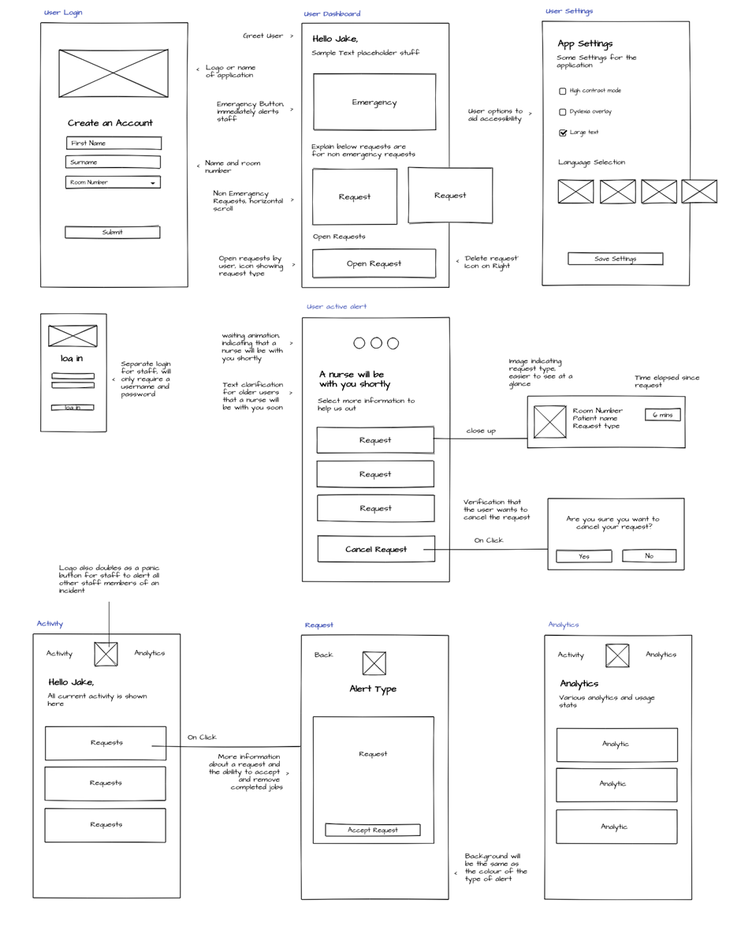

**Features and functionality**

The chosen features and functionality to be included in the application were considered when researching the problem the application aims to tackle. The features can be broken down into three categories: ‘staff user’ features, ‘user’ features and ‘admin’ features.

*figure 2 – Context Data Flow Diagram*

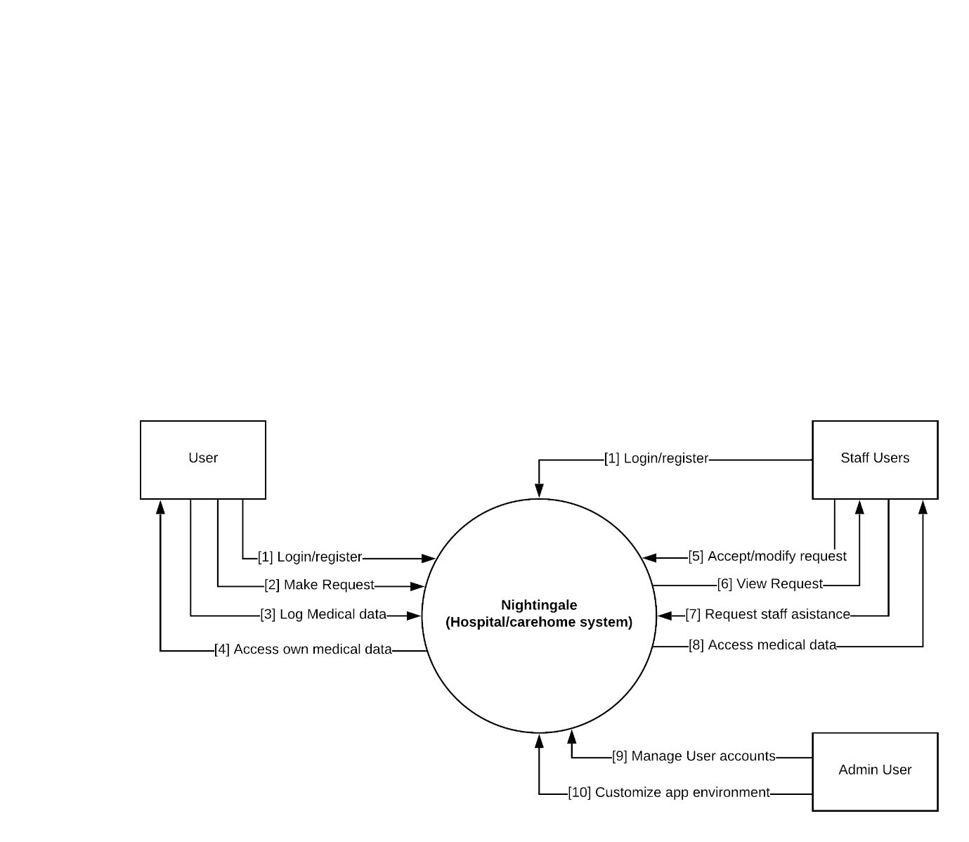

The context diagram above shows how the features and functionality will aid the interaction with each of the entities and the system (or Nightingale as it was named) as a whole. Each of the numbered subsystems have been broken down and explained, the design of each has been supported with the use of high-fidelity designs and a UML diagram as this is a better representation of user interaction than DFD’s.

1. Login/Register functionality (*figure 2.1 appendix*) will provide a secure login for staff users and users alike. This will be essential for security and individual accounts to differentiate between users. The register functionality will provide a new user with the ability to create an account. Password reset functionality would also be beneficial.

*figure 2.1 – login/register UML*

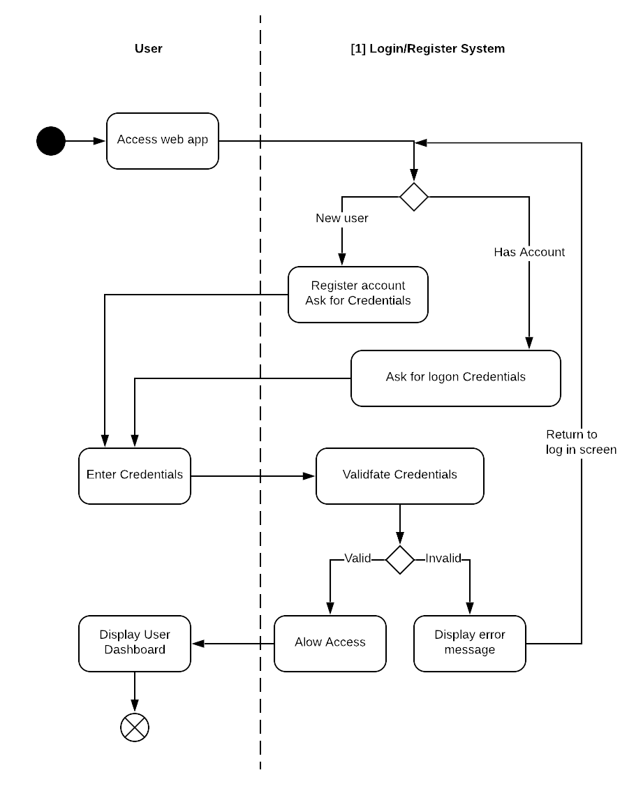

*High fidelity designs, Login/Register*

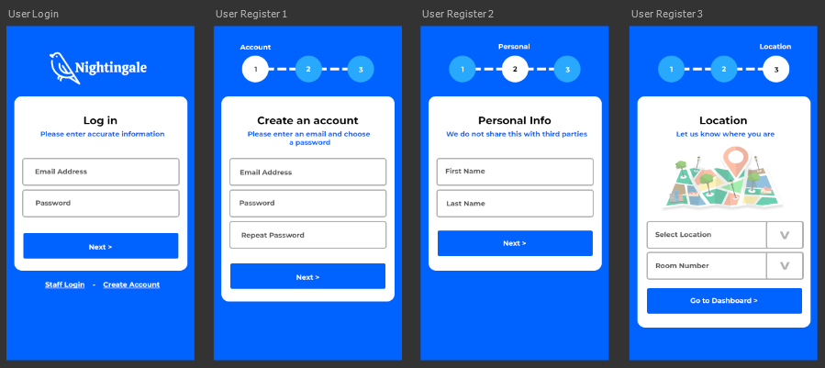

1. Make request (*figure 2.2*) will be the main user feature in the application and will allow a user to make a specific request that the staff users can then respond to. The requests will provide data, such as the user concern and urgency of assistance necessary.

*figure 2.2 – Make Request UML*

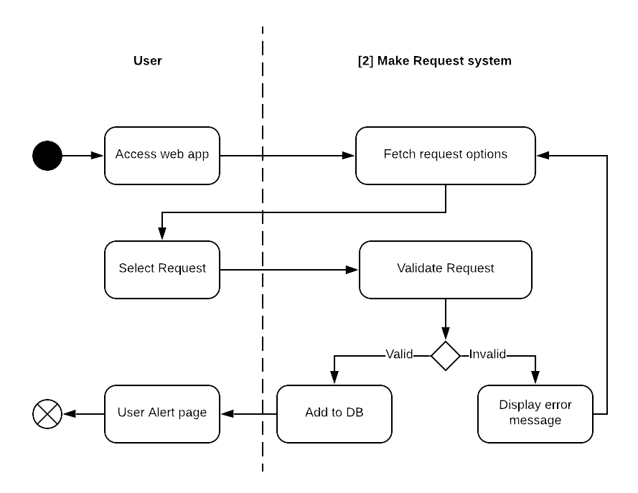

*High fidelity designs, User dashboard*

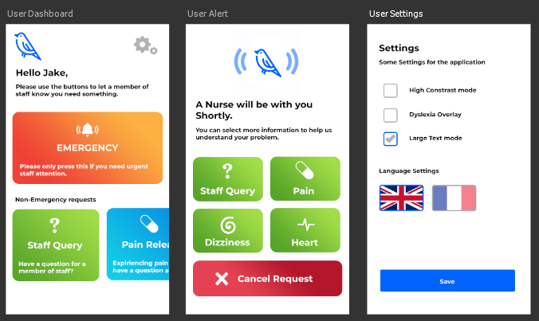

1. Log medical data (*figure 2.3 appendix*) is another user feature that will allow the user to log their mood and blood glucose level themselves. This data will be accessible to users and staff users.

*figure 2.3 – log medical data UML*

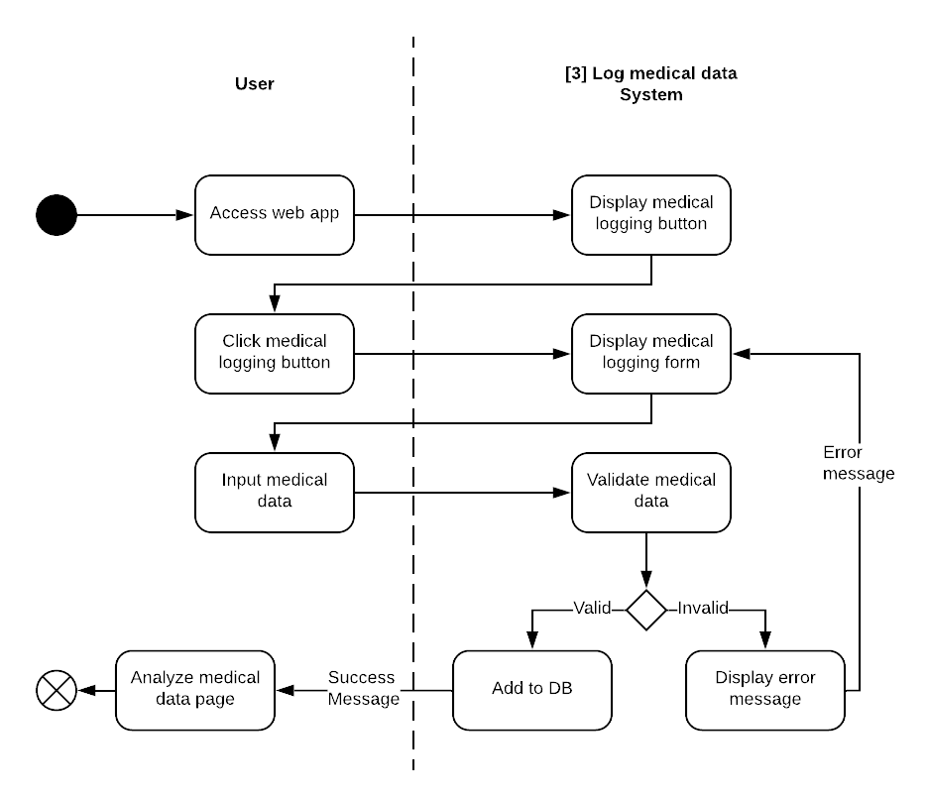

1. Access own medical data (*figure 2.4 appendix*) will be used by the user to see the personal data that they logged. A user will only be able to view their own data for security reasons.

*figure 2.4 – Access own medical data UML*

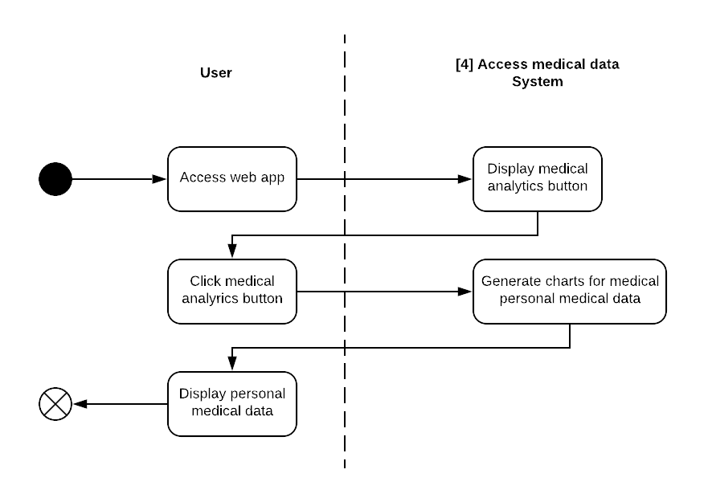

1. Accept/Modify request (*figure 2.5 appendix*) is a staff user functionality and will only be available to staff users. It will allow a staff user to handle a user request, by accepting and completing the request via the GUI the staff users can manage patients/residents more effectively.

*figure 2.5 – Accept/Modify request UML*

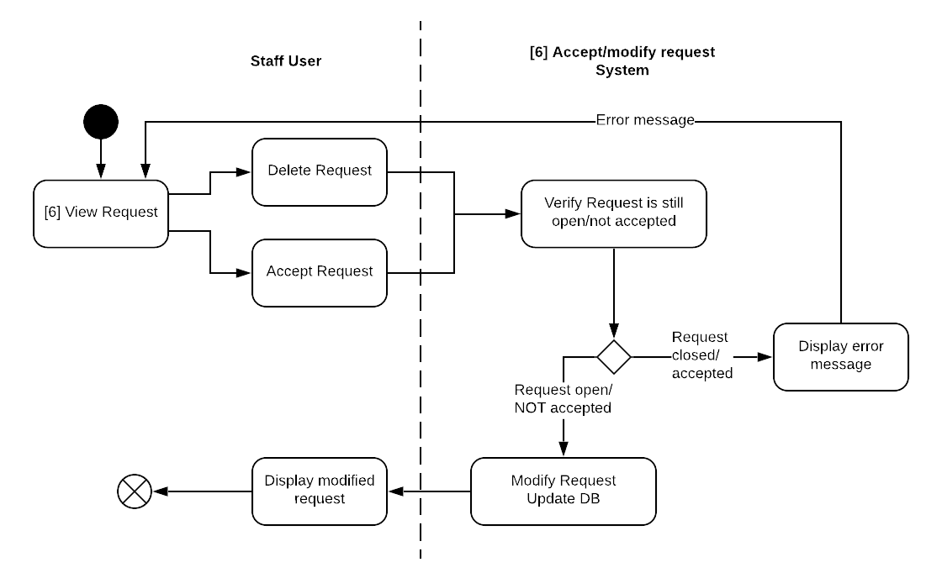

1. View request (*figure 2.6 appendix*) Staff users must be able to view all non-completed requests in a logical and helpful manner, allowing a staff user to choose specific requests to complete as a priority.

*figure 2.6 – View request UML*

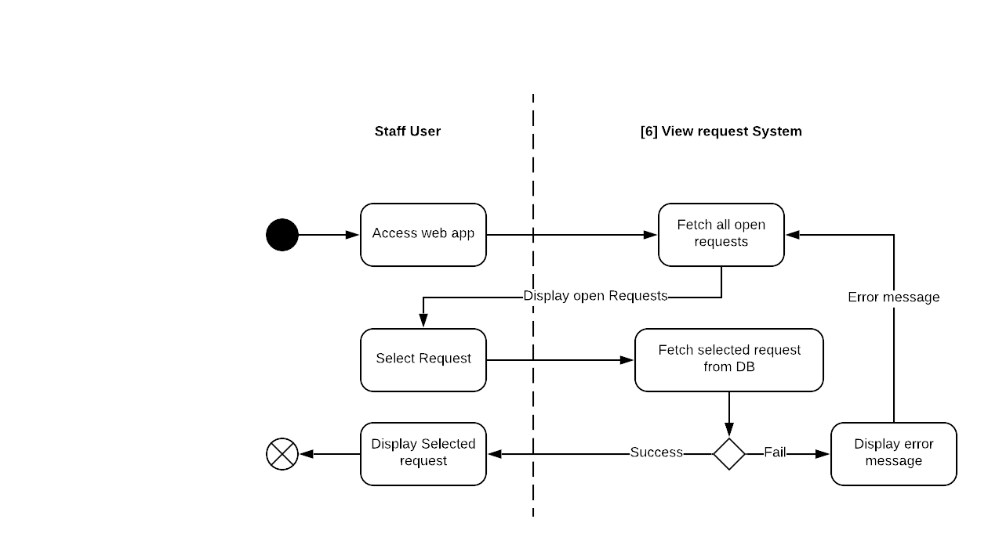

*High fidelity designs, Staff user request*

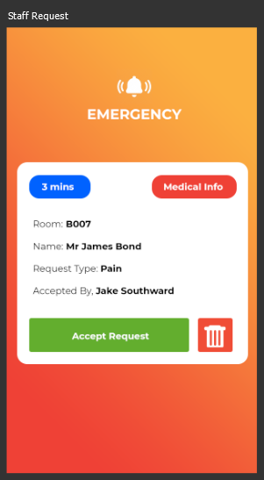

1. Request staff assistance (*figure 2.7 appendix*) Staff users have a feature to safeguard themselves from danger or request assistance from other staff members directly through the app. The staff assistance feature will be in a prominent position in case of emergency.

*figure 2.7 – Request staff assistance UML*

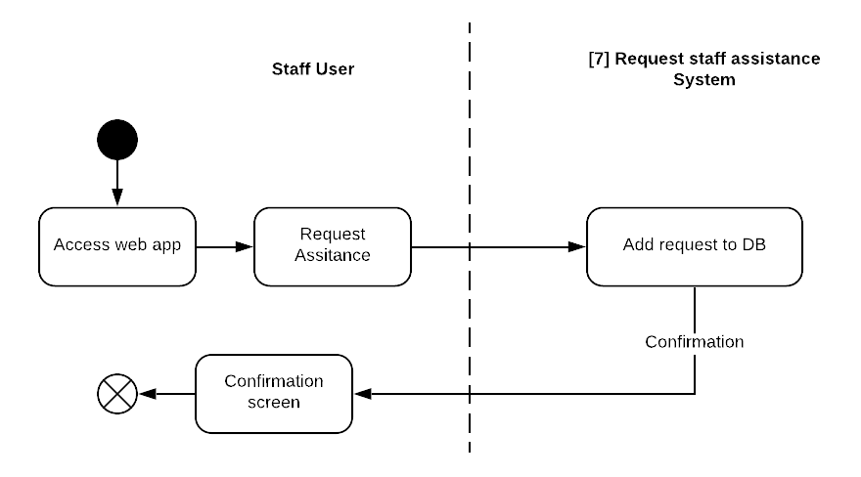

1. Access medical data, staff members will have access to all patients medical data that has been submitted by a user, allowing quick access for diagnostic purposes.
2. Manage user accounts, this admin functionality is intended for changing of staff users passwords and viewing/deleting user and staff user accounts.
3. Customize app environment This will only be available to admin accounts and will allow changes to the user GUI such as, adding and removing types of requests for more customizable functionality. This is important for different types of environments; a care home environment will have very different needs to a hospital or dental practice.

**Data Visualization Considerations**

Research was done in the literature review on Data Visualization relevant to the project and the key points that were considered in designing the Glucose logging charts were: Simplicity in data (Tufte, 2001), selecting meaningful axis ranges (Tufte, 2001), Use of lines when connecting chronological data (Kelleher and Wagener, 2011). Below are examples of the graph type that will be used. As you can see the removal of unnecessary legends on the chart makes for a cleaner look, as the data is simple and is based off a single reading at a range of times in one day navigation through the days will be necessary. Additionally the data is presented with adequate margins on the X and Y to aid readability.

Blood glucose level (mg/dL)

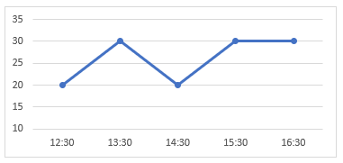

**Personas to aid design**

The use of personas helps outline the goals of users and how it reflects the functionality of the web application. Three main persona areas are reviewed: Design, User experience, and Features and Functionality. Each persona will be referred to using the identifying numbers in square brackets. Personas can be found in the design documentation section of the appendices.

*Design – Design fit for purpose*

Young Hospital Patient [1] would likely be impartial to the design but may appreciate clarity of text or colour choices. Whereas middle aged hospital patient [4] would likely find the simplicity of the design beneficial to using the application.

*User experience - Understanding how to navigate the experience, and see all relevant content*

Young Hospital Patient [1] should have no problem with the user experience. However Hospital patient [4] may need some time to understand basic functionality, this is a key consideration when developing the application. A video tutorial or information screen when first using the application could combat this issue. Additionally making the application as simple as possible without compromising features is a necessity. Considering easy navigation minimal navigation could be achieved by having one main feature screen for the patients to use rather than separating the content across multiple pages.

*Features and functionality - features useful to achieve user goals*

The users and staff users alike would find many necessary features in the application, middle aged patient [4] may require assistance or have an enquiry from a member of staff regarding their upcoming operation. Therefore the use of non-emergency requests may be considered. Staff members would likely wish to view patient glucose logging therefore appropriate ways to search for a patient must be considered.

**Database Design**

When designing the database it was important to generate a maintainable database without data redundancy. By deciding what data will be necessary it was possible to reduce the amount of data to be stored. And by separating into multiple tables it leaves room for additions and potential updates. Below is a diagram showing relationships within the database followed by a data dictionary showing data types, NULL value, and the default value.

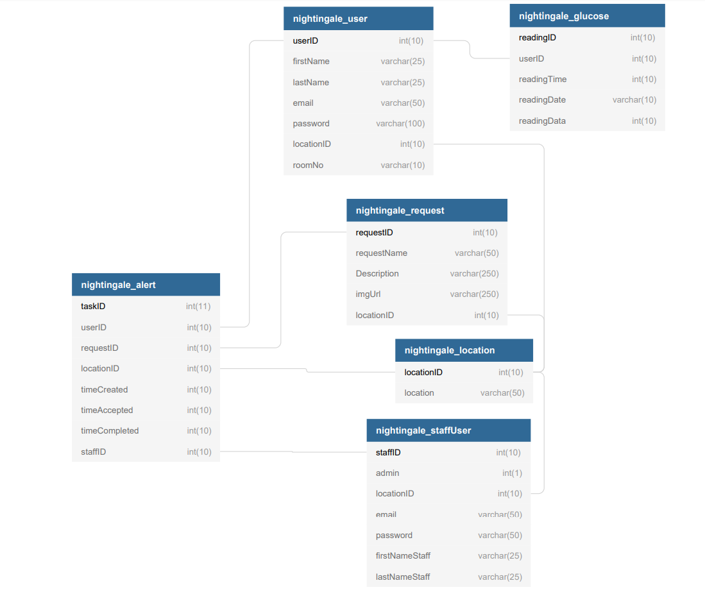

**Data Dictionary**

|  |  |  |  |  |  |  |  |  |  |  |  |  |  |  |  |  |  |  |  |  |  |  |  |  |  |  |  |  |  |  |  |  |  |  |  |  |  |  |  |  |  |  |  |  |  |  |  |  |  |  |  |  |  |  |  |  |  |  |  |  |  |  |  |  |  |  |  |  |  |  |  |  |  |  |  |  |  |  |  |  |  |  |  |  |  |  |  |  |  |  |  |  |  |  |  |  |  |  |  |  |  |  |  |  |  |  |  |  |  |  |  |  |  |  |  |  |  |  |  |  |  |  |  |  |  |  |  |  |  |  |  |  |  |  |  |  |  |  |  |  |  |  |  |  |
| --- | --- | --- | --- | --- | --- | --- | --- | --- | --- | --- | --- | --- | --- | --- | --- | --- | --- | --- | --- | --- | --- | --- | --- | --- | --- | --- | --- | --- | --- | --- | --- | --- | --- | --- | --- | --- | --- | --- | --- | --- | --- | --- | --- | --- | --- | --- | --- | --- | --- | --- | --- | --- | --- | --- | --- | --- | --- | --- | --- | --- | --- | --- | --- | --- | --- | --- | --- | --- | --- | --- | --- | --- | --- | --- | --- | --- | --- | --- | --- | --- | --- | --- | --- | --- | --- | --- | --- | --- | --- | --- | --- | --- | --- | --- | --- | --- | --- | --- | --- | --- | --- | --- | --- | --- | --- | --- | --- | --- | --- | --- | --- | --- | --- | --- | --- | --- | --- | --- | --- | --- | --- | --- | --- | --- | --- | --- | --- | --- | --- | --- | --- | --- | --- | --- | --- | --- | --- | --- | --- | --- | --- | --- | --- | --- |
| *nightingale_alert*   |  |  |  |  | | --- | --- | --- | --- | | Column | Type | Null | Default | | taskID | int(11) | No |  | | userID | int(10) | No |  | | requestID | int(10) | No |  | | locationID | int(10) | No |  | | timeCreated | int(10) | Yes | *NULL* | | timeAccepted | int(10) | Yes | *NULL* | | timeCompleted | int(10) | Yes | *NULL* | | staffID | int(10) | Yes | *NULL* |   *nightingale_request*   |  |  |  |  | | --- | --- | --- | --- | | Column | Type | Null | Default | | requestID | int(10) | No |  | | requestName | varchar(50) | No |  | | Description | varchar(250) | No |  | | imgUrl | varchar(250) | Yes | *NULL* | | locationID | int(10) | Yes | *NULL* |   *nightingale_user*   |  |  |  |  | | --- | --- | --- | --- | | Column | Type | Null | Default | | userID | int(10) | No |  | | firstName | varchar(25) | No |  | | lastName | varchar(25) | No |  | | email | varchar(50) | No |  | | password | varchar(100) | No |  | | locationID | int(10) | Yes | *NULL* | | roomNo | varchar(10) | Yes | *NULL* | | *nightingale_glucose*   |  |  |  | | --- | --- | --- | | Column | Type | Null | | readingID | int(10) | No | | userID | int(10) | No | | readingTime | int(10) | No | | readingDate | varchar(10) | No | | readingData | int(10) | No |   *nightingale_location*   |  |  |  | | --- | --- | --- | | Column | Type | Null | | locationID | int(10) | No | | location | varchar(50) | No |   *Nightingale_staffUser*   |  |  |  | | --- | --- | --- | | Column | Type | Null | | staffID | int(10) | No | | admin | int(1) | No | | locationID | int(10) | No | | email | varchar(50) | No | | password | varchar(50) | No | | firstNameStaff | varchar(25) | No | | lastNameStaff | varchar(25) | No | |

* 1. Implementation

The system developed was a web-based system, which comprised of three main components: web-based database, front end or graphical interface GUI and a back end to handle requests and communicate with the database. The system runs on a cloud computing instance to provide adequate security, reliability, and future scalability.

**Site Map**

*User Account Access /* Lock *Staff Account Access /  Admin Access Only*



Landing page

User Register Account

User Login

User Tutorial



User Dashboard



** User Alert Screen

User Settings



User Glucose Logging



Staff Login

 Staff Dashboard

 Staff View Request

 Staff analytics

 Staff Glucose data

** Admin dashboard

* + 1. Database Implementation

For the database MySQL was utilized effectively to create the construct that data is stored within. MySQL is used in the tech stacks of Uber, Airbnb and Amazon showing its impressive scalability (Mysql.com). MySQL specifically is used as it can handle Data security successfully combined with its high performance and flexibility it was a clear choice for use with a web application. Additionally it can be used to naturally with PHP to develop the functionality of the application. The database consists of several tables seen in the images below allowing the addition of elements for future expansion or modifications.

**Database Tables**

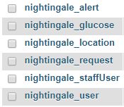

**nightingale_alert**

This is the primary table for user ‘alerts’. When a user makes a request it will be stored here, using other tables primary keys as reference.

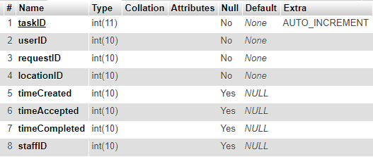

**nightingale_user**

Table for a user’s information and settings.

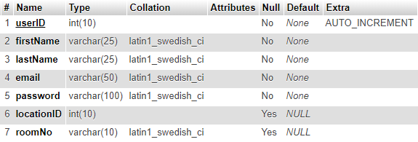

**Nightingale_staffUser**

Staff user information and settings

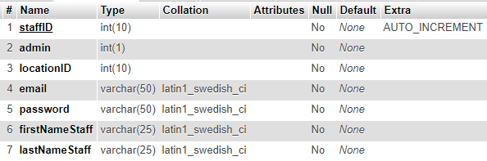

**Nightingale_location**

Table for locations, separated so that geolocations could be added as a future improvement.

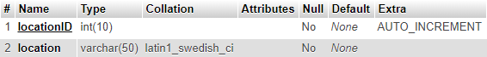

**nightingale_request**

Used to store request types that are displayed on the user dashboard

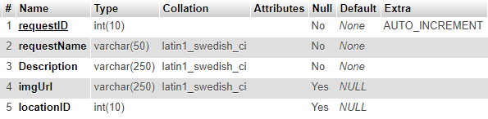

**nightingale_glucose**

This table is used to store user glucose readings.

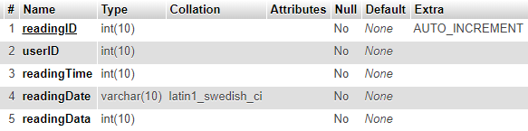

* + 1. Back End Implementation

PHP was used extensively for the back end of the website, allowing the MySQL database to be queried to display relevant content. Many of the operations performed server side are found in a functions.php file making it easier to troubleshoot and going forward maintain. Below essential PHP and SQL is explained, although complete code can be found in the appendices.

**Database connection function**

Database connection was achieved Using PDO and could be called using a connection function (shown below). This allowed other functions to connect more easily with a simple function call.

|  |  |
| --- | --- |
|  |  |

**Displaying Tasks on dashboard**

The function getTasks shows all non-completed tasks on the staff dashboard so that they can be viewed and responded to by a staff user. The SQL joins multiple tables to get all of the relevant information about a particular user request from the nightingale_alert table. An example request is shown below.

In the SQL below the joins are visible. The query where clause will only fetch rows from the table that have not been completed or accepted yet. The query also prevents tasks from different location to the staff user being shown.

|  |  |
| --- | --- |
|  |  |

**Displaying Accepted Tasks**

The getAcceptedTasks function is very similar to the getTasks function, however it shows tasks that the currently logged in staff user has accepted. Below is the SQL for the WHERE statement.

|  |  |
| --- | --- |
|  |  |

**AJAX to auto load tasks**

The tasks loaded by the getTasks and getAcceptedTasks functions have to automatically refresh without the whole page constantly reloading. The AJAX load method was utilised to automatically refresh the tasks without manually refreshing. It simply loads the php functions separately on an interval of 5 seconds, this ensures that the tasks are constantly updated from the perspective of the staff user.

|  |  |
| --- | --- |
|  |  |

Constantly loading the tasks presented a problem as the icons would take time to load every time that the AJAX loaded, to prevent this unnecessary loading the image icons are preloaded.

**Getting Glucose Data**

The glucose data is held in the format shown below using a php timestamp to store the reading time. This is important to plot the data accurately on a graph.



The getGlucoseData function receives two parameters (Query Date, UserID) and responds with a string. The string is in the correct format for the google charts API to use to plot a graph of the glucose data. An example response would be “[new Date(2015, 0, 1, 18, 47), 200]”

|  |  |
| --- | --- |
|  |  |

It was also important to allow users and staff users to modify requests, this was possible again through functions in the functions.php file. Making use of the SQL DELETE statement it was possible to remove a specific task from the alert table. Using the INSERT statement a new row could be added to the database for a new user or staff user request. UPDATE statement was utilised to allow a staff user to modify a request.

DELETE

|  |  |
| --- | --- |
|  |  |

INSERT

|  |  |
| --- | --- |
|  |  |

UPDATE

|  |  |
| --- | --- |
|  |  |

* + 1. GUI Implementation

This was developed using HTML and JavaScript to supplement the front-end functionality and usability. The front-end languages were used in compliance with the w3 standards and aimed to be written semantically where possible making use of HTML5 tags. CSS was used to style the webpages and provide CSS based transitions/animations. jQuery was used for from validation and jQuery Ui was used for search autocomplete and tabbed content when registering an account. Google charts was utilised for glucose data visualisation. Essential functionality and aspects are explained below.

**Responsive Layout**

It was important for the layout to work well on multiple screen sizes (primarily mobile devices) so Semantic HTML and CSS was used for the front end throughout. CSS media queries provided the ability to change styling based on screen size effectively. Another method to generate responsive layouts is the use of flexbox, this allows horizontally aligned content that resizes fluidly. The final aspect to responsive layout was using view width and height dimensions rather than pixel dimensions. Example below.

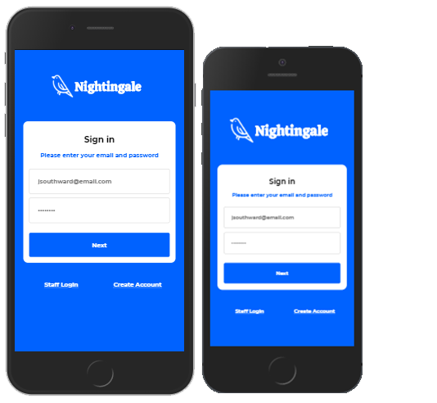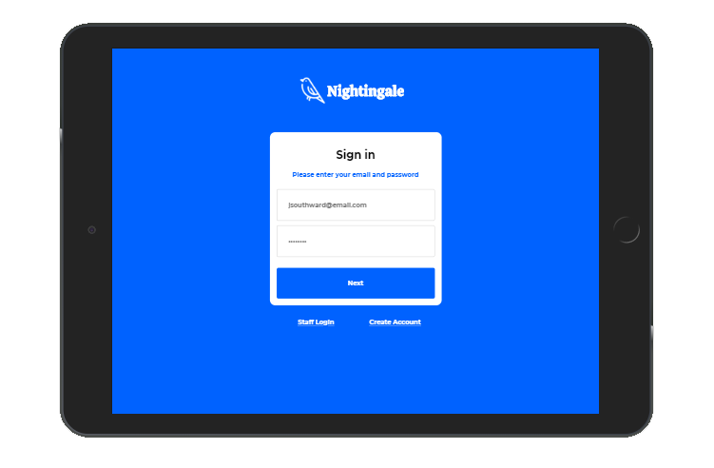

**Glucose Chart Data visualisation**

It was necessary to display the logged glucose data in the form of a graph to better visualise the data. Google charts (Google Developers. 2020) allows data to input in the form of an array via a JavaScript API. Below is an image of the final chart.

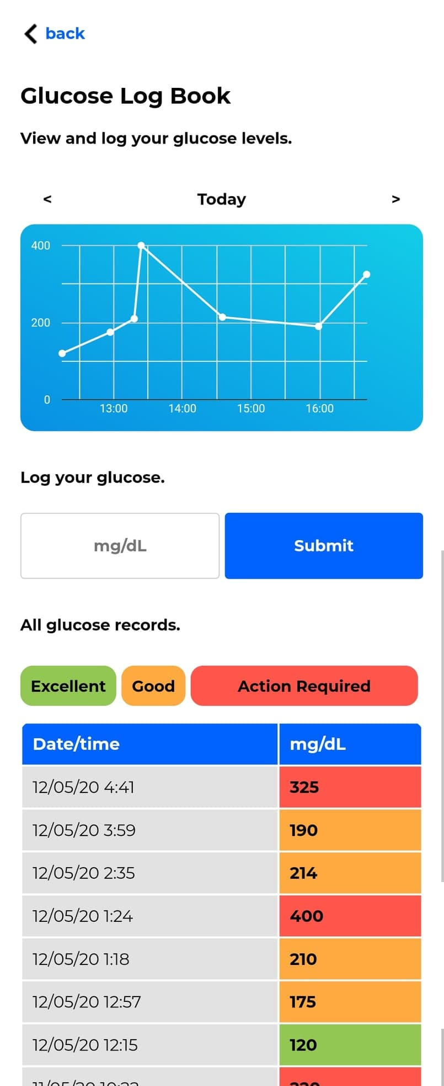

Below is the JavaScript for google the chart which uses the getGlucoseData php function to return the data in the correct format (a JavaScript array) for the API. The getGlucoseData function takes two parameters the time; taken from the URL header in the form of a GET response and the userID that is stored in SESSION variable upon logging into your account.

|  |  |
| --- | --- |
|  |  |

However there were complications with styling the chart. It was not possible to set the chart width as a percentage and the width of the chart needed to be responsive for any device width. The way that worked best was to use JavaScript to find the width of the parent div element in the DOM and use that as the width of the chart.

The chart controls found above the chart were challenging to accomplish however the final result is very simple. By using php GET, it was possible to set the requested time as a variable in the URL. The getGlucoseData function would then receive the requested time as a parameter to display the graph for a specific day. The controls altered the GET variable in the URL using an anchor tag, and simply adding or subtracting one day (86400 seconds) from the variable controlled the day displayed on the graph.

|  |  |
| --- | --- |
|  |  |

**CSS Animation**

For the user request page, after they make a request from their dashboard, an animated icon is displayed to represent a bird singing to reassure the user that the request has been sent. This was achieved using CSS3 animations. To ensure that the animation was visible on all browsers, the webkit animations were used in addition to the regular animations.

*Animation Frames*



|  |  |
| --- | --- |
|  |  |

**Glucose log user search**

It was important that the staff could find user glucose data easily. When searching for glucose data a search field is present for the staff user to input a user’s name. The search field needed to have an autocomplete for patient names to aid searching.

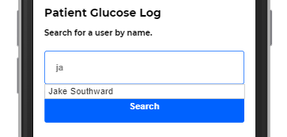

To generate the dropdown autocomplete seen above jQuery Ui was used. Using the php function autocompleteUser it was possible to fetch relevant users from the database and display them in the form of a JavaScript array. Example data format - {value: "1",label: "Jake Southward"}. This array in the form of a string could be given to the jQuery autocomplete code seen below. For the glucose data to be shown on a chart it was necessary to get the userID to use as a parameter in the getGlucoseData function, this was added to a hidden field (#userID).

|  |  |
| --- | --- |
|  |  |

* 1. Cloud Server Implementation

Amazon AWS Setup

* 1. Database Security

**Delete MySQL history file**

The deletion of any history files (MySQL history file ~/.mysql_history) is essential, as it contains detail that is important for the instillation and configuration of MySQL. Once the server is running correctly it should be removed, as it can result in exposure of passwords or critical database user information. This information is often useful for hackers to gain access to data.

**Encrypting Data**

The encryption of all passwords within the database was priority, this although not impervious to attack makes the job much harder. PHP provides a method to hash data (md5) which cannot be reversed. This is an example of one-way encryption and was enough security for this solution. Two-way encryption is another option that allows decryption of encrypted data using a key pair.

**SQL Injection**

Injection of SQL code into input fields on a website is one of the most common attacks. This was prevented with the use of PDO prepare statements that escape strings before SQL runs the statement, removing any malicious SQL or code before it is run on the database. Without sufficient care to sanitize data somebody could input SQL with the intent to damage or remove your data.

* 1. Coding Standards

Semantic HTML was utilized throughout the project providing a better base for search engine optimization and translation as a future feature. Accessibility is greatly improved with the use of semantic markup, allowing screen readers to better interpret the pages.

PDO or PHP data objects defines a lightweight interface for accessing databases. The use of PDO over alternatives such as MySQLi has many advantages. PDO provides a data-access abstraction layer, making it possible to connect to most types of database using the same functions. Which can greatly improve the maintainability of a project, should the database change over time. PDO as previously mentioned provides a prepare method allowing the data inputted into a query to be sanitized and escaped, minimizing the risk of SQL injection. PDO was used extensively throughout the project for the aforementioned justifications.

Reusability was encouraged throughout the project, by creating versatile functions that could be used again and again, code did not have to be duplicated. Ultimately reducing the footprint of files for the application.

Code was commented throughout the project to aid maintainability. Going forward there could be potential for other developers to collaborate on the project therefore a good standard is to describe the functionality of each function used. Indentation similarly was useful for returning to code that you have not looked at for a while and to clearly mark the opening and closing of tags and functions. Indentation is essential for readability and needless to say, it was used throughout.

1. Testing

**Development Testing**

Throughout the development phases a chart was developed and expanded as the project grew. Its purpose was testing for bugs and error handling within the application (table below).

|  |  |  |  |
| --- | --- | --- | --- |
| ID | Test | Expected Outcome | Actual Outcome |
| 1 | Logging in with correct details. | Should redirect to dashboard. | PASS – worked as intended. |
| 2 | Leaving login input blank and pressing submit. | Should prevent login and display message “all input fields are required”. | PASS – worked as intended. |
| 3 | Inputting correct email in login form but incorrect password. | Should prevent Login and display message “incorrect email or password”. | PASS – worked as intended. |
| 4 | Leaving register input blank and pressing submit. | Should prevent registering and display message “all input fields are required”. | PASS – worked as intended. |
| 5 | Trying to access dashboard page without being logged in. | Redirect to login page. | PASS – worked as intended. |
| 6 | Admin add location. Leaving the location name field blank. | Should prevent user from submitting and display message “name required”. | Partial PASS – did not prevent user from submitting in all browsers but did prevent data reaching database and error message was displayed. |
| 7 | Admin add new account. Leaving a field blank. | Should prevent user from submitting and will display message “all input fields are required”. | PASS – worked as intended. |
| 8 | Admin add new account. Inputting valid details. | Should add new account and display confirmation message. | PASS – worked as intended. |
| 9 | Logging own user glucose. | Should add glucose data to database. | PASS – worked as intended. |
| 10 | Staff Logging users glucose levels. | Should add glucose data to database for user inputted into field. | PASS – worked as intended. |
| 11 | Staff Logging users glucose levels without entering user. | Should hide the glucose reading form until user is selected from search. | PASS – worked as intended. |
| 12 | Navigating through days on glucose logging page. | Should be able to move forward and backward days when viewing glucose. | PASS - worked as intended. |
| 13 | Making a request from the dashboard. | Once clicked it should display the request pending page notifying you to wait for a nurse to respond. | PASS - worked as intended. |
| 14 | Cancelling a request. | Should ask for confirmation of cancelling. If you confirm it will cancel the request. | PASS - worked as intended. |
| 15 | Staff, Viewing a patient request. | Should display the request in full. | PASS - worked as intended. |
| 16 | Viewing glucose data from the request screen. | Should show the relevant users glucose log. | PASS - worked as intended. |
| 17 | Accepting a request. | Should set the status of the request to accepted and redirect to the staff dashboard. | PASS - worked as intended. |
| 18 | Completing a request. | Should set the status of the request to completed and redirect to the staff dashboard, where the request should not be displayed. | PASS - worked as intended. |
| 19 | Deleting a request | It should first ask for confirmation, if confirmed it should remove the request. Leaving the user on a success page, stating “request deleted”. | PASS - worked as intended. |
| 20 | Using the staff panic button. | It should first ask for confirmation, if confirmed it should make a request that is visible on every other staff account for that location. | PASS - worked as intended. |
| 21 | Removing the panic request. | It should first ask for confirmation, if confirmed it should remove the panic request. | PASS - worked as intended. |
| 22 | Dark mode. | Allow dark mode on all user pages. | PASS - worked as intended. |
| 23 | Large text mode. | Allow larger text on all user pages. | PASS - worked as intended. |
| 24 | Admin dashboard access. | Should display the admin dashboard button to admin accounts. | PASS - worked as intended. |
| 25 | Admin dashboard access by URL. | Should prevent non admin accounts from accessing, redirect to login page. | PASS - worked as intended. |
| 25 | Staff feature access | Should prevent non staff accounts from accessing, redirect to login page. | PASS - worked as intended. |
| 26 | Adding a new request via the admin dashboard. | Should allow the creation of new requests, preventing missing fields with error message “all fields are required”. | PASS - worked as intended. |
| 27 | Editing an existing request. | Should allow the modification of existing requests, leaving a field blank should give an error “all fields are required”. | PASS - worked as intended. |

**User Testing**

User testing comprised of a survey to fill in while performing tasks on the application, rating them for usability and ease of understanding.

**Evaluation**

1. Evaluations and Conclusions

**Achievements**

Research

This project aimed to *“Develop an advanced web service/app to help staff prioritise patient requests in unique hospital and care home settings.”* The final software solution undoubtably achieves this. Pairing together a semantic HTML5 front end, concise and secure MySQL database, robust and effective PHP to manage the requests, and effective data visualisation. Each system is better analysed when broken down into steps, evaluating each subsystem for certain metrics; fitness for purpose, how robust each system is, user experience and accessibility.

**Login/register functionality.**

The login and user register functionality is suitable for the scale of the project, providing separate staff and user login screens appropriately. The process of registering an account has been simplified by separating the form across a progress bar at the top. This ensures that the content is readable, and that the inputs are clearly arranged. A dropdown was used for the location, simplifying the process.

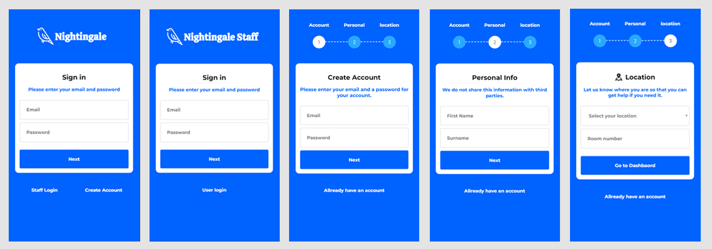

The system is robust, escaping all strings used as inputs using PDO, also providing validation with JavaScript (client side) and php (server side) to check that all required fields are populated. Accessibility has been considered by using minimal styling and clear contrasting colours. As well as the use of tab indexing on the form elements. Security was addressed by encrypting the password before it is sent to the database. Although security could have been improved with the use of two-way encryption of all of the data in the database. Overall the system meets its requirements.

**User Request System.**

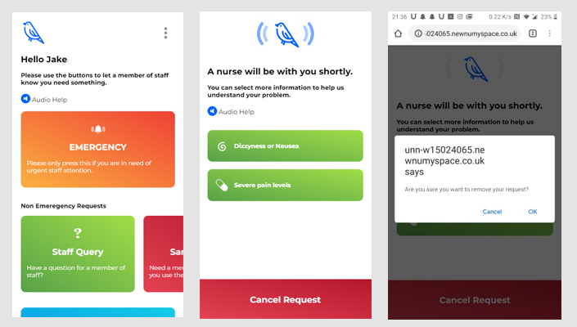The user request system is the most vitally important as it allows a user to request help from staff members in the hospital or car home. It performs its specified aims, allowing requests and request management. The goal was to create an accessible interface that could be understood by a wide demographic of users. The use of intuitive colours and contrasting text aids readability. Icons symbolize the actions buttons perform; the buttons were designed to look like a button further adding to the intuitive design. Text to speech is utilized throughout allowing a user to listen to instructions. However, functionality is basic and could be improved with the multi-language support of (Google Cloud, 2020) googles cloud translate for example.

The system is robust, and customizable for the needs of the users. This was achieved technically with the use of on-screen dialogs and location (hospital/care home etc.) specific content. The request content is added via the admin functionality allowing customizability to the dashboard based on the needs of the location its being used. PDO was used again to ensure sanitization of data between the app and the database. The request functionality could be improved by having subcategories for requests allowing a more detailed analysis to the staff of the nature of the request.

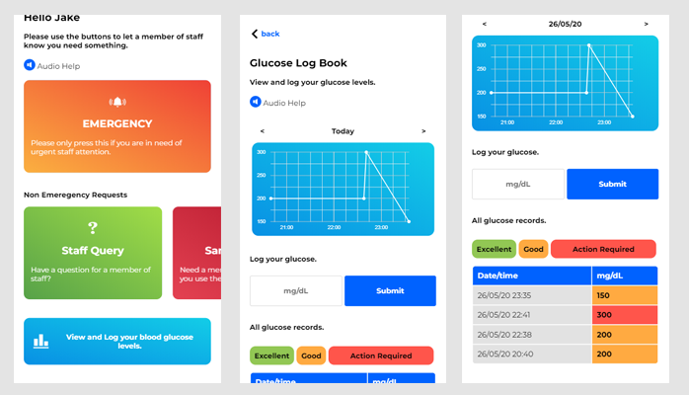**User glucose view and log.**

This functionality took great inspiration from the literature review, addressing data visualisation in HCI. The final outcome is a useful glucose log, that could stand alone as a basic glucose logging app. It provides a graph plotting glucose throughout the day and a table of data for each day giving brief guidance on when action should be taken for your glucose level, with the use of colours. It also makes use of the text to speech functionality seen across the application.

Throughout user testing a colour-blind participant struggled to differentiate the colours in the data table, showing that a text-based analysis may be more accessibility friendly. This was overlooked during the design phase and could be improved in the future.

**User settings, dark mode, large text mode, change location.**

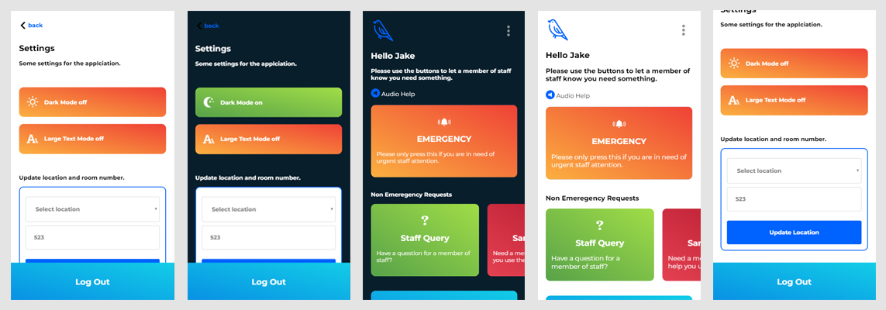User settings was not heavily discussed in the design phases and it took shape more organically as the project progressed. The key features of the settings page are: Dark mode (high contrast mode), large text mode, and the ability to change your location (in case you move to a different ward or room) and the ability to log out of your user account.

The first setting serves the accessibility of the application with study suggesting high contrast is better for readability. The second is again for readability particularly for older users that may suffer degenerative ability in sight, allowing the text size to be increased.

The ability to change your location settings serves a more functional requirement of the overall alerts system, as patients may move around within a hospital during their stay. The toggleable elements are robust, using the user database to store the settings, so returning to the application they are remembered. In a more marketable product this page would contain further settings such as a password change facility and language options. One aspect that was present in the designs was the multi-language option which under time restraints never made it into the final application, this sadly would prevent non-English speakers from using the application, this should be a primary consideration for future updates.

**Staff user view requests**

The view requests functionality allows staff users to interact with the patients requests, allowing staff users to view the details of requests as well as, accept, complete, and delete user requests. This functionality is essential to the whole requests subsystem and meets its functional requirements discussed in its design (chapter 3.1).

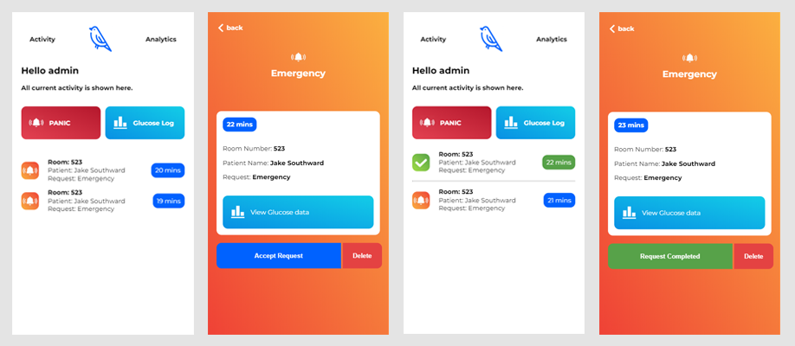

From a usability perspective the layout is simplistic, sticking to the colour scheme that allows for high contrast visibility of the text and icons. The status of a request (pending/accepted) is categorised for easy viewing. As the questionnaire data suggested it would have to deal with a potential for 20+ requests open at the same time, the dashboard is scrollable extending down as far as necessary for the number of open requests. The requests are ordered on the time created, to ensure that they are completed as fast as possible. Icons are visible showing the type of request, allowing easy and quick interpretation. Subsequently allowing high priority tasks to be completed first.

Another feature is the ability to jump straight to a user’s medical data (glucose log), making the job of finding a patients glucose data even quicker.

**Staff glucose data search**

This functionality allows staff users to view and record patient glucose data. It allows all of the functionality of the user glucose logging feature. But it has a search field that can be used to search for a particular user when inspecting their glucose. the primary functionality is simple allowing only basic navigation back and forward days when viewing glucose levels. This could be improved with a calendar selector to select more freely; it was also common for test users to swipe on the graph in attempt to move forward and backward days. Adding a swipe event to change the day being viewed could make the action more intuitive.

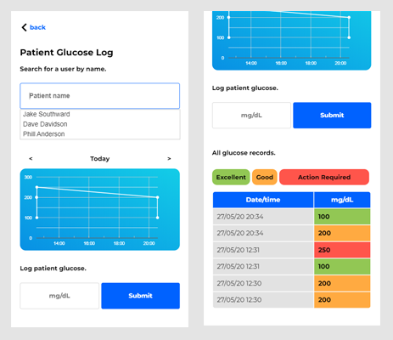

**Staff panic button and panic alert notification.**

The staff panic button serves a simple function, it alerts members of other members of staff that they need assistance. It is positioned in a prominent place on the staff dashboard and is bright red allowing for easy intuitive use. It has a dialog box to confirm your intention when clicked, thus preventing accidental activation.

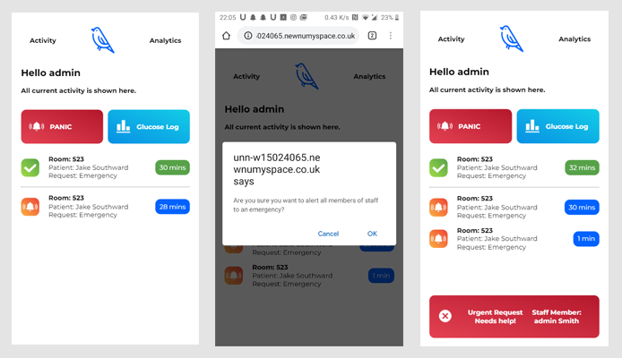

Once activated all staff members in the location that the staff member is in will receive a popup on the dashboard of the application. The alert can be stopped by the person that made the request by clicking the cancel button. This functionality was essential due to the evidence of violence and harassment towards hospital and care home staff, evidenced in the literature review(2.2) and survey results (2.5) chapters.

**Staff analytics and Admin dashboard.**

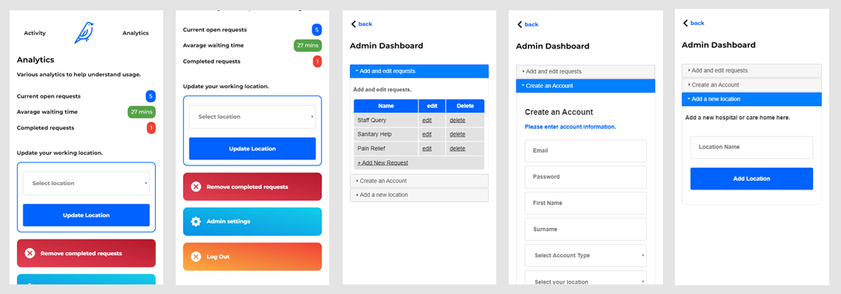The staff analytics are there to provide valuable information and encouragement to the staff of their accomplishment. The analytics would be useful to management or supervisors. The analytics page also allows staff users to change their location, as many care workers often work in more than one location throughout the week. It would be useful to take location data to suggest a change in location (e.g. “you are close to Newcastle; would you like to change your location settings to Newcastle RVI”) would be a useful future direction. The analytics data can also be reset from an admin account.

Admin settings is another option for admin accounts only. The admin page allows editing of requests that are displayed on the user dashboard, the creation of staff accounts and adding of new locations. These features make the app more customizable for a more individual application. Requests with custom icons, titles and text can be added to the dashboard and used as request types by the users. The admin dashboard functionality makes use of an accordion style menu saving space and aiding usability. As with the rest of the application PDO sanitizes any data aiding in prevention against attack. The admin dashboard is reliable and robust, adequately preventing errors with on screen validation of the forms. The accordion menu could easily be expanded for future admin features, such as viewing and editing staff users information.

**Future Direction**

2 way encrypting all personal information in database

AI and mathematics for glucose level prediction

<https://link.springer.com/article/10.1007/s41666-019-00059-y>

<https://www.hindawi.com/journals/jhe/2019/8605206/>

**Considerations**

The key considerations in research were

The key considerations in design were

The key considerations in security were

Technical considerations

Non functional requirements

Legal issues

Professional, social, ethical issues

**Project management**

**Conclusions**

The functionality implemented in the software solution meets its brief including all functional requirements stated in the design chapter (3.1). The final software solution provides adequate capability to aid staff in prioritizing patient care in unique environments. This is possible through a customizable interface that allows staff and patients to interact effectively. The matter of weather it could improve current systems in hospitals and care homes is difficult to answer. As the software solution provides a different way of responding to requests, based on priority. As future research it would be interesting to compare the use of a system that prioritises requests against current systems of first ‘buzz’ first served.

1. References

Mysql.com. 2020. MySQL - MySQL Customers. [online] Available at: https://www.mysql.com/customers/.

World Health Organization, 2011. *World report on disability 2011*. World Health Organization. [online] Available at: https://apps.who.int/iris/bitstream/handle/10665/44575/9789240685215_eng.pdf

Medium. 2020. 10 Best Fonts for Improving Reading Experience. [online] Available at: https://medium.com/productivity-revolution/10-best-fonts-for-improving-reading-experience-6171ce199e97.

IMERI, A., 2014. Prototyping a touch-based communication application for social support of the elderly focusing on UI aspects. [online] Available at: https://www.politesi.polimi.it/bitstream/10589/89925/1/2014_04_Imeri.pdf.

Mykityshyn, A., Fisk, A. and Rogers, W. (2002). Learning to Use a Home Medical Device: Mediating Age-Related Differences with Training. *Human Factors: The Journal of the Human Factors and Ergonomics Society*, [online] 44(3), pp.354-364. Available at: https://journals.sagepub.com/doi/pdf/10.1518/0018720024497727.

Wheeler Atkinson, B., Bennett, T., Bahr, G. and Walwanis Nelson, M., 2007. Development of a Multiple Heuristics Evaluation Table (MHET) to Support Software Development and Usability Analysis. Lecture Notes in Computer Science, [online] pp.563-572. Available at: https://link.springer.com/chapter/10.1007/978-3-540-73279-2_63

Tognazzini, B. (2003). First principles of interaction design. *Interaction design solutions for the real world.* [online] Available at: http://www.asktog.com/basics/firstPrinciples.html

Asktog.com. 2020. Asktog: First Principles of Interaction Design. [online] Available at: https://asktog.com/basics/firstPrinciplesOldEdition.html.

Fitts, P.M., (1954). The information capacity of the human motor system in controlling the amplitude of movement. Journal of experimental psychology, 47(6), p.381. [online] Available at: https://pdfs.semanticscholar.org/634c/9fde5f1c411e4487658ac738dcf18d98ea8d.pdf.

Nielsen Norman Group. 2020. Information Scent: *How Users Decide Where to Go Next*. [online] Available at: https://www.nngroup.com/articles/information-scent/.

Shneiderman, B. (1998). Designing the user interface: Strategies for effective human-computer interaction. Reading, MA: Addison Wesley Longman.

Nielsen, J., (1994). Heuristic evaluation. In J. Nielsen & R. L. Mack (Eds.), Usability inspection methods (pp. 25-62). New York: John Wiley & Sons.

Dix, A., Finlay, J., Abowd, G. D., and Beale, R., (1992), Human Computer Interaction, 2nd ed

Congdon, N., O'Colmain, B., Klaver, C.C., Klein, R., Muñoz, B., Friedman, D.S., Kempen, J., Taylor, H.R. and Mitchell, P., 2004. Causes and prevalence of visual impairment among adults in the United States. Archives of Ophthalmology (Chicago, Ill.: 1960), 122(4), pp.477-485.

Hendrickson, G., Doddato, T. and Kovner, C. (1990). How Do Nurses Use Their Time?. JONA: The Journal of Nursing Administration, [online] 20(3), p.31. Available at: https://europepmc.org/abstract/med/2313373.

GOV.UK. 2020. Data Protection. [online] Available at: https://www.gov.uk/data-protection.

Google Developers. 2020. Charts | Google Developers. [online] Available at: https://developers.google.com/chart.

Ons.gov.uk. 2020. Language in England And Wales - Office for National Statistics. [online] Available at: https://www.ons.gov.uk/peoplepopulationandcommunity/culturalidentity/language/articles/languageinenglandandwales/2013-03-04#proficiency-in-english.

Tufte, E., 2001. The Visual Display Of Quantitative Information. Cheshire, Conn.: Graphics Press.

Kelleher, C. and Wagener, T., 2011. Ten guidelines for effective data visualization in scientific publications. Environmental Modelling & Software, 26(6), pp.822-827.

Bronner, G., Peretz, C. and Ehrenfeld, M., 2003. Sexual harassment of nurses and nursing students. Journal of advanced nursing, 42(6), pp.637-644.

Finlayson, B. (2002). Mind the gap: the extent of the NHS nursing shortage. *BMJ*, [online] 325(7363), pp.538-541. Available at: https://www.bmj.com/content/325/7363/538.extract.

Leuteritz, J.P., Widlroither, H., Mourouzis, A., Panou, M., Antona, M. and Leonidis, A., 2009, July. Development of Open Platform Based Adaptive HCI Concepts for Elderly Users. In International Conference on Universal Access in Human-Computer Interaction (pp. 684-693). Springer, Berlin, Heidelberg. Available at: https://link.springer.com/content/pdf/10.1007%2F978-3-642-02710-9_76.pdf.

Andersson, G., Cuijpers, P., Carlbring, P., Riper, H. and Hedman, E., 2014. Guided Internet‐based vs. face‐to‐face cognitive behavior therapy for psychiatric and somatic disorders: a systematic review and meta‐analysis. World Psychiatry, 13(3), pp.288-295.

Søgaard Neilsen, A. and Wilson, R.L., 2019. Combining e‐mental health intervention development with human computer interaction (HCI) design to enhance technology‐facilitated recovery for people with depression and/or anxiety conditions: An integrative literature review. International journal of mental health nursing, 28(1), pp.22-39.

Morrison, L.G., Yardley, L., Powell, J. and Michie, S., 2012. What design features are used in effective e-health interventions? A review using techniques from critical interpretive synthesis. Telemedicine and e-Health, 18(2), pp.137-144.

Pagliari, C., 2007. Design and evaluation in eHealth: challenges and implications for an interdisciplinary field. Journal of medical Internet research, 9(2), p.e15.

Jobe, W., 2013. Native Apps Vs. Mobile Web Apps. International Journal of Interactive Mobile Technologies (iJIM), 7(4), p.27.

Developer.apple.com. 2020. About Objective-C. [online] Available at: https://developer.apple.com/library/archive/documentation/Cocoa/Conceptual/ProgrammingWithObjectiveC/Introduction/Introduction.html.

.NET Blog. 2020. Announcing the Release of the .NET Framework for Windows Phone 8 | .NET Blog. [online] Available at: https://devblogs.microsoft.com/dotnet/announcing-the-release-of-the-net-framework-for-windows-phone-8/.

Android Developers. 2020. Android Developers. [online] Available at: https://developer.android.com/guide.

mobiForge. 2020. Build Web Apps for iPhone Using Dashcode - Mobiforge. [online] Available at: https://mobiforge.com/design-development/build-web-apps-iphone-using-dashcode.

Arewefastyet.com. 2020. Firefox Performance Dashboard. [online] Available at: https://arewefastyet.com/.

Google Cloud. 2020. Cloud Translation | Google Cloud. [online] Available at: https://cloud.google.com/translate.

1. Appendices
2. Terms of Reference
3. Design Documentation
4. Diagrams
5. Code snippets
6. Test plan
7. Questionnaire Results
8. Gannt Charts
9. eLogbook
   1. Terms of Reference

Next Page

KV6003 : Individual Computing Project

### Project Terms of Reference

Jake Southward : w15024065 Computer Science with Web

Supervisor: Yilun Shang

Second marker: Kamlesh Mistry

General Computing Project

Contents

a) Project Title 19

b) Background to Project 19

c) Proposed Work 20

d) Aims of Project 21

e) Objectives 21

f) Skills 21

g) Sources of Information / Bibliography 22

h) Resources – Statement of hardware / software required 23

i) Structure and contents of project report 23

1. Introduction 24

2. Analysis 24

3. Synthesis 24

4. Evaluation and Conclusions 25

5. References 25

6. Appendices 25

j) Marking Scheme: General Computing Project 26

k) Project Plan – Schedule of activities 27

1. Project Title

***Investigate the effective ways to improve hospital/ care-home nurse coordination with the use of a web application.***

1. Background to Project

I have chosen to investigate how medical / care home settings can use modern technology to aid the elderly and hospital patients. Primarily looking at call systems for staff to respond in a timely manner to an incident. A study across 36 hospitals identified three key targets for improving the efficiency of nursing time management: “documentation, medication administration, and care coordination.” (Hendrich, 2008). For my project I will be undertaking the development of a web-based system that will attempt to combat the issue of care coordination in a suitable way.

Nurses spend an average of only 31% of their time with patients and some studies suggest greater use of computers may reduce time spent on non-essential nursing functions. (Hendrickson, Doddato and Kovner, 1990) Undoubtably the use of technology has improved since 1990, however a more recent study (Bagheri Lankarani, 2019) focusing on care coordination and wasted time outlined the need for hospital information systems that can analyse the workload. One of the study’s reason for wasted time was the hospital information systems, showing this trend towards better use of technology is still relevant.

The proposed project is of interest as in the UK there is severe strain on the National Health Service and its resources. Since 1997 the number of nurses leaving the profession has outstripped the number of entrants (B Finlayson, 2002). Leaving less nurses to handle more patients, resulting in less time spent with patients.

This project aims to research and develop a web-based application that could combat the strain on health services by taking advantage of the devices most people already own. Throughout the project it will push me to use everything I know and to learn new things to develop a working product that can be accessible and easy to use for my target audience (staff and people in care). I additionally will explore how my solution could be scaled and configured to a larger user base and used in multiple settings.

The requirement for design is even more specific when creating a system for less traditional or diverse users. The natural process of aging comes with an array of degenerative ability concerns, including visual problems, hearing loss, motor skills may be impaired, and the retention of memory may affect the operation of a new application. Despite these concerns the statistics seem to show an unexpected trend. From 2012 to 2015 elderly (65+) smartphone users have almost doubled in the UK (A Berenguer, 2017). This indicates that as we move into a more technology driven world, more and more elderly people and patients in hospitals will have access smartphones / tablets.

The design of applications for diverse users, such as the elderly or impaired is very important, however the method of training to use the application could be just as vital for specific users. A study (Mykityshyn, Fisk and Rogers, 2002) showed that older participants struggled to retain the training for a home medical device when compared to a younger age group. Additionally when the elderly users were given video training rather than a manual they performed almost as well as the younger age group at retaining the ability to use the device. This shows how a visual tutorial has a greater impact for specific user demographics than plain text manuals.

1. Proposed Work

I will perform necessary research and develop a web-based application/ service that would allow a user to request assistance from a member of staff expanding the existing call system in care homes and hospitals. Where my idea improves on current systems is the request would be made using an application on a smartphone/ tablet and the staff using the same application would be able to see any current requests. This would allow staff with the use of the app to prioritise care and easily see all current requests and how they are being handled in the palm of their hand. Additional optional information could also be sent with the request, for example one patient may be experiencing extreme pain whereas another may have a question for a member of staff, with the system I plan to develop brief information will be available for the staff allowing specific prioritisation as each request happens.

One of the first tasks will involve a questionnaire that will aid the design process. The questionnaire will be targeted at the staff that will be using the web application. This will be crucial in determining the specific functionality of the application as it will be an insight into how the nurses work, but crucially how they can work better with my application.

My literature review will address necessary aspects of the workflow of a nurse to ensure the application is fit for purpose. Furthermore I will need to research the potential issues that may arise when developing an application for the elderly and disabled, for example accessibility and user experience design.

I will generate extensive design documentation that will guide me through the development of the application, giving me specific requirements when programming the front end. During the development of my web-based application I will be using the most relevant methods to achieve my goals. I will be developing the front end of my application using HTML, JavaScript and CSS as I would like to consider multiple browsers and compatibility with devices. My application must be accessible on all screen sizes to encourage easy use for my target demographics.

I will make use of a MySQL web-based database to securely store and access relevant data. In conjunction with the database PHP will be used to deliver the content to the user and encrypt sensitive information to and from the database. Security will be a key aspect of the system as it will be dealing with potentially sensitive data; I will need to overcome this throughout the project.

When the application is at a level where functionality is useable, testing will be very important. Regular testing will help guide any changes as I approach the end of development, this should eradicate any problems that have been overlooked during the design phase. User testing will tie all of the testing together giving a more real world look at how people use my application with very little instruction. My application should be intuitive enough for people to make requests and respond to requests without formal training. So as I develop, I will be thinking of tasks that could be user tested.

1. Aims of Project
   1. Investigate if hospital/care home alert systems could be improved with the use of a web application in line with smartphone adoption trends.
   2. Develop an advanced web service/app to help staff prioritise patient requests in unique hospital and care home settings.
2. Objectives
3. Perform a literature review of HCI and accessibility for the elderly and disabled, to determine the unique considerations for each group.
4. To research relevant information on both staff and patient users to ensure that the application is fit for purpose.
5. Gather information from people with experience in care home or hospital environments using a questionnaire. And ask questions about their workflow and current systems in place for patients to alert a member of staff.
6. Produce high quality design documentation to aid the development of my application. Including wireframes and photoshop mock-ups, as well as technical diagrams to show the movement of data and relationships in the database.
7. Develop an accessible patient call system application interface that is fit for my user demographic. I will use latest trends in design to achieve a visually appealing look.
8. Implement a MSQL database for storing data needed by the application.
9. Securely connect the front end and database to display relevant information from the database in real time.
10. Generate a list of tasks for volunteer test users to perform, testing normal and abnormal use of the application, to ensure it is fit for purpose.
11. To produce a test plan when performing meticulous product testing, and user testing of my application.
12. Evaluate the final application to determine how it meets my brief, taking into consideration all research and requirements.
13. Skills

Throughout the project I will need to rely on many of my skills, many that I have gained from university study and personal development outside of study. Also I may have to build on my skills. Below is a table of the expected skills in this project.

|  |  |
| --- | --- |
| **Skill** | **Acquired / Will Acquire by** |
| Web Programming (HTML, PHP, SQL) | Relational Databases Module (KC4000), Web Programming Modules (KF5002, KF4009), Personal Web Development for Clients. |
| Web Design (Photoshop, CSS) | Personal Web Development for Clients, Web programming module. (KF4009) |
| Research Skills | Most University Modules have included Report/ essay writing. |
| Interpersonal Skills | Effective communication with participants of user testing/ questionnaire. Attained from pervious group tasks and client communication outside of university. |
| Organizational Skills | Previous assignment deadlines have taught me the importance of this skill. |
| Testing code | Testing and profiling Programming throughout University projects. (KF5012, KF5008) |
| User Testing | I will improve my skills in this area by reading relevant books from Northumbria library. |
| Web Security (SSL) | It may be beneficial to learn about the use of SSL to further defend my application. |

1. Sources of Information / Bibliography

Hendrich, A. (2008). A 36-Hospital Time and Motion Study: How Do Medical-Surgical Nurses Spend Their Time?. *The Permanente Journal*, [online] pp.25-34. Available at: https://www.ncbi.nlm.nih.gov/pmc/articles/PMC3037121/.

Finlayson, B. (2002). Mind the gap: the extent of the NHS nursing shortage. *BMJ*, [online] 325(7363), pp.538-541. Available at: https://www.bmj.com/content/325/7363/538.extract.

Berenguer, A., Goncalves, J., Hosio, S., Ferreira, D., Anagnostopoulos, T. and Kostakos, V. (2017). Are Smartphones Ubiquitous?: An in-depth survey of smartphone adoption by seniors. *IEEE Consumer Electronics Magazine*, [online] 6(1), pp.104-110. Available at: https://ieeexplore.ieee.org/abstract/document/7786986.

Mykityshyn, A., Fisk, A. and Rogers, W. (2002). Learning to Use a Home Medical Device: Mediating Age-Related Differences with Training. *Human Factors: The Journal of the Human Factors and Ergonomics Society*, [online] 44(3), pp.354-364. Available at: https://journals.sagepub.com/doi/pdf/10.1518/0018720024497727.

Hendrickson, G., Doddato, T. and Kovner, C. (1990). How Do Nurses Use Their Time?. *JONA: The Journal of Nursing Administration*, [online] 20(3), p.31. Available at: https://europepmc.org/abstract/med/2313373.

Bagheri Lankarani, K., Ghahramani, S., Roozitalab, M., Zakeri, M., Honarvar, B. and Kasraei, H. (2019). What do hospital doctors and nurses think wastes their time?. *SAGE Open Medicine*, [online] 7, p.205031211881368. Available at: https://www.ncbi.nlm.nih.gov/pmc/articles/PMC6503588/ [Accessed 19 Nov. 2019].

1. Resources – Statement of hardware / software required

**Microsoft Office**

I will use Microsoft Word for the bulk of the report and appendices, this software is available on university machines and my personal laptop. Microsoft excel will be used for the Gantt chart and any results gathered throughout the project.

**GitHub**

This will be used for version control when producing the web application, this will be beneficial as it will make a backup that is available on any machine and all changes will be logged showing a detailed update log through the project.

**Adobe Photoshop**

This will be vital for producing low and high-fidelity designs of the application I wish to develop. Licensed access to Photoshop is available in the university labs and library.

**Personal laptop**

A personal laptop with access to required software will be necessary as it will give me the freedom to work at home or university on the project.

1. Structure and contents of project report

**Title Page**

Any necessary identifying elements of the report, title, author, module etc.

**Declaration of Authorship**

This is a signed declaration that all of the contents of the report and the work described in it are your own work. It also states ethical guidelines and a description of how the work will be used.

**Acknowledgements**

This section will describe any sources that may be acknowledged in the making of the report, for example companies, my project supervisor or university staff.

**Abstract**

The purpose of an abstract is to provide the reader with essential information relating to the report. It will also briefly summarise the basis of the report, so that a reader can easily determine the contents.

**List of Contents**

A page numbered list of the content within the report, for easier reading and navigation.

1. Introduction

The introduction will provide more information, expanding on the abstract. It will also overview the objectives and give a reason for including them in the report. I will introduce the web application I aim to develop. The aims of the project will be introduced here with a breakdown of how it will be achieved.

1. Analysis

The analysis section will comprise of three chapters, problem identified, Literature review and Software Implementation.

* 1. **The Problem**

First, I will identify the problem area of my project and explore the potential problems associated with the demographics (elderly and disabled) that I will be developing the application for.

* 1. **Literature Review**

In this section I will critically analyse existing research and literature related to the problems explored in the previous section. I will also research potential solutions to the problems in the project area that will allow the application development to take shape. I will use mostly online journals and books available in Northumbria Library for my research.

* 1. **Software Implementation**

This section of the analysis I will explain the choices when developing the web application such as tools and techniques and the rationale when choosing specific languages for development.

1. Synthesis

The Synthesis will consist of three chapters, Design, Implementation and Testing. And will discuss the work carried out to develop my application from an idea to a working tested outcome.

3.1. **Design**

Section will explain the design process in terms of how each aspect of the application relates to my initial brief. Interface Design as well as system design, as it needs to be useable and also fit for purpose (having necessary features).

3.2. **Implementation**

The process of developing the nurse call application including all technical aspects. Such as language choice, coding standards, code concepts as well as the database and security.

3.3 **Testing**

This section will involve the testing of the application throughout development and at the end when test users use my application to ensure it is fit for purpose. Throughout this process I will document any testing.

1. Evaluation and Conclusions

This section will be a summary of all that was achieved throughout the project including specific research and a detailed analysis of the final web application after testing and amendments. It is important to discuss any future direction or considerations attained from the project. Additionally I will relate to the literature that I reviewed earlier in the report using my own results and conclusions.

1. References

A list of references used to validate facts when composing my report using Harvard referencing standard.

1. Appendices
2. Terms of Reference
3. Design Documentation
4. UML Diagrams
5. Code Snippets
6. Test plan and Results
7. Gannt Chart
8. Meeting Documentation / eLogbook
9. Marking Scheme: General Computing Project

**Report: 60%**

|  |  |
| --- | --- |
| **Section** | **Weight** |
| Abstract & Introduction | 5% |
| Analysis | 30% |
| Synthesis | 30% |
| Evaluation & Conclusions | 30% |
| Presentation | 5% |

**Product: 30%**

|  |  |
| --- | --- |
| **Section** | **Weight** |
| **Fitness for Purpose**   * Accessibility & Language * Suitability of implemented functionality * Cross device compatibility | 70%  **Breakdown**  0 – 15  0 – 40  0 – 15 |
| **Build Quality**   * Code Quality * Quality of design * Quality of testing | 30%  **Breakdown**  0 – 10  0 – 10  0 – 10 |

**Viva: 10%**

1. Project Plan – Schedule of activities

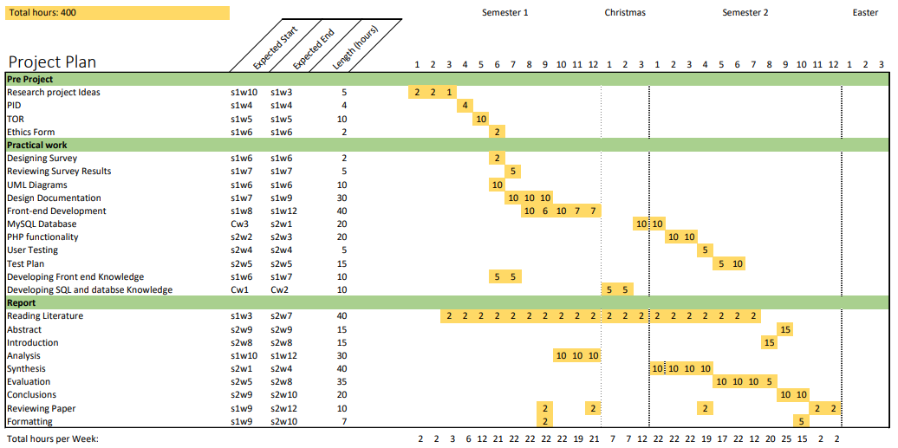

* 1. Design Documentation

*figure 1.2 – Initial Wireframe design of dashboards*

*figure 1.3 – Colour Scheme*



*figure 1.4 – High fidelity designs, Login/Register*

**

*figure 1.5 – High fidelity designs, User dashboard*

**

*figure 1.6 – High fidelity designs, User medical data*

Process of inputting medical data

*figure 1.7 – High fidelity designs, Staff user dashboard*

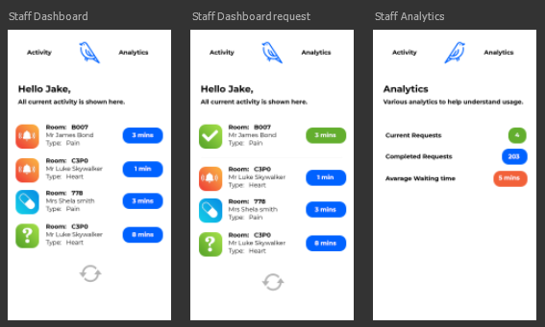 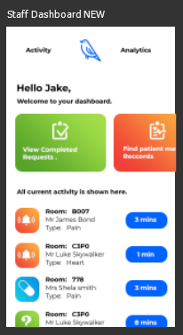

*figure 1.8 – High fidelity designs, Staff user request & medical data*



*figure 1.9 – High fidelity designs, Staff user view medical data*

Process of viewing patient medical data

* 1. Diagrams

*figure 2.1 – login/register UML*



*figure 2.2 – Make Request UML*

**

*figure 2.3 – log medical data UML*

**

*figure 2.4 – Access own medical data UML*

**

*figure 2.5 – Accept/Modify request UML*

**

*figure 2.6 – View request UML*

**

*figure 2.7 – Request staff assistance UML*

**

|  |  |
| --- | --- |
| **Persona:** | Young Hospital Patient [1] |
| **Photo:** |  |
| **Fictional Name:** | Mathew Johnson |
| **Job title/ responsibilities:** | Bar staff in a city bar |
| **Demographics:** | 21 years old University Student |
| **Environment:** | He has very good computer skills. Very adaptable to learning how a new application or website works. Has an iPhone and a laptop. Regularly uses Uber, Facebook and Instagram. Usually uses his iPhone to browse websites and shop online. |
| **Tasks and Goals:** | Currently in hospital for a short stay due to appendicitis. Wakes up the day after an operation and is in a lot of pain.  - Alerting staff that he is in a lot of pain and feels nauseous. |

|  |  |
| --- | --- |
| **Persona:** | Young hospital Nurse [2] |
| **Photo:** | woman having blood pressure monitor |
| **Fictional Name:** | Gemma Watson |
| **Job title/ responsibilities:** | Works in a hospital as a Nurse. |
| **Demographics:** | 27 years old Has a boyfriend (Unmarried) Nursing Graduate  2 years’ experience as a nurse |
| **Environment:** | She has good computer skills. Very adaptable to learning how a new things. Has an iPhone and a tablet. Regularly uses Netflix, Facebook, and twitter. Uses her tablet to watch Netflix shows. |
| **Tasks and Goals:** | Working in the hospital as a nurse.   - Performing medication rounds  - Personal care for patients  - Patient admissions  - Responding to Call bell system |

|  |  |
| --- | --- |
| **Persona:** | Experienced Hospital Nurse [3] |
| **Photo:** | Image result for 40 year old nurse" |
| **Fictional Name:** | Cecilia Smith |
| **Job title/ responsibilities:** | Works in a hospital as a head Nurse. |
| **Demographics:** | 45 years old Married for 20 years  20 years’ experience as a nurse |
| **Environment:** | Intermediate computer user. Sometimes slow to learn how new apps work. Has an android Phone. Regularly uses Facebook, fitness apps and shops online. Uses her phone to buy new clothes online and track her fitness. |
| **Tasks and Goals:** | Working in the hospital as a head nurse.  - Personal care for patients  - Patient admissions  - Responding to Call bell system  - wound dressings  - iv fluid/antibiotic administration  - observations  - discharge planning |

|  |  |
| --- | --- |
| **Persona:** | Hospital patient [4] |
| **Photo:** | Image result for builder" |
| **Fictional Name:** | Kevin Wright |
| **Job title/ responsibilities:** | Has his own building firm. |
| **Demographics:** | 45 years old Married for 5 years  2 children |
| **Environment:** | Rarely uses a computer. Sometimes slow to learn how new apps work. Has an android Phone. Uses his phone to make calls and email clients. |
| **Tasks and Goals:** | In hospital with a severe leg injury he acquired at work.  - Requesting Pain medication.  - making an enquiry to nurses about when he will be in surgery. |

* 1. Code snippets
  2. Test Plan and Results

1. Questionnaire Results

|  |  |  |  |  |  |  |  |  |  |  |
| --- | --- | --- | --- | --- | --- | --- | --- | --- | --- | --- |
| ID | Q1. | Q2. | Q3. | Q4. | Q5. | Q6. | Q7. | Q8. | Q9. | Q10 |
| 1 | hospital | Taking patients to the radiography room | 10 to 20 | Have pager, buzzer and on wards | Alarms | 25-40 | Agree | Strongly Agree | Agree |  |
| 2 | hospital | Care of patients and medication administration | 10 to 20 | Buzzer or find me | Alarm | 16-40 | Strongly Agree | Agree | Agree |  |
| 3 | hospital | medication rounds, personal care for patients, wound dressings, cannulation, iv fluid/antibiotic administration, catheterisation, observations, ward rounds, discharge planning, admissions | 20+ | Call bell system | loud buzzer makes noise until we answer the call bell | 16-64 | Strongly Agree | Agree | Strongly Agree |  |
| 4 | hospital | Medicine rounds, patient care | less than 10 sometimes, more than 20 other times | get our attention or press the bedside buzzer | Hallway monnitor and sounding alarm | 25-40 | Strongly Agree | Agree | Strongly Agree |  |
| 5 | care-home | Meal handling. caring of residents, bathing/take to the toilet, buzzer responses, entertainment. | less than 10 | Each resident has a personal buzzer in their rooms and buzzers in all toilets and living rooms. | buzzer alarm in corridors that inform you of room that needs assistance. | 16-64 | Neutral | Agree | Agree |  |
| 6 | care-home | Helping elderly patients with day to day care | 10 to 20 | ask for assistance - alarm | We'll get around to it after higher risk residents | 41-64 | Agree | Neutral | Agree | N/A |
| 7 | care-home | care for residents, assist everyday activites. Feed, dress, bathe. Handling medication | 5 | Buzzer in room | buzzer in the passageways | 41-64 | Neutral | Strongly Agree | Neutral |  |
| 8 | care-home | Responding to buzzers, aiding personal hygeine, medication administration, overseeing patients are cared for | 10 to 20 | Buzzer in room | buzzer in hallway | 16-64 | Agree | Agree | Agree |  |
| 9 | care-home | medication , bathing and personal care, respond to patient needs | 20 | Buzzer | Buzzer in hall | 16-40 | Agree | Strongly Agree | neutral |  |
| 10 | care-home | Engaging with residents, feeding meals, making beds and changing, dressing residents | 10 to 15 | Buzzer in room | Alarm machine that tells you the room number in hall | 25-64 | Agree | Agree | neutral |  |
| 11 | care-home | Feeding, bathing, medication administration, all round care | 10 | Buzzer in room, toilets and living area | buzzer in hall | 16-65+ | neutral | Agree | Agree |  |
| 12 | Hospital | Iv fluids, oral medication administration, medical record | 15-20 | Ask for help or buzzer system, pager | Alarm | 25-64 | Strongly Agree | Strongly Agree | Agree |  |
| 13 | care-home | Cream and oitment appliance, bed making, dressing, bathing, feeding, assisting in hospital trips | 15 to 20 | Buzzer system | Buzzer in hallway | 25-64 | neutral | Agree | neutral |  |
| 14 | care-home | Repsonding to calls, snack and meal rounds, personal care assistance, medication | 10 | Buzzer or ask carer | Buzzer in corridoor | 25-64 | neutral | Agree | Agree |  |
| 15 | care-home | Medication administration, bathing, and dressing, responding to resisdents needs | 10 | Buzzer is room | Buzzer with room number in corridoor | 25-64 | Agree | Agree | neutral |  |
| 16 | hospital | Patient care, hospital rounds, medical administration, engaging with patients | 20 or more | Pager, buzzer system | Alarm | 25-64 | Agree | Agree | Strongly Agree |  |

* 1. Gannt Charts
  2. Meeting Documentation / eLogbook

**Meeting 1:**

|  |  |
| --- | --- |
| **Date and time of meeting:** | **As scheduled:** Yes/No |
| **Brief description of work done since last meeting:** | |
| **Number of hours spent on project since last meeting:** | |
| **Questions/items to discuss at meeting (agenda):** | |
| **Agreed tasks for next meeting:** |  |
| **Documents discussed /any other issues:** |  |
| **Date and time of next meeting:** | |

**Meeting 2:**

|  |  |
| --- | --- |
| **Date and time of meeting:** | **As scheduled:** Yes/No |
| **Brief description of work done since last meeting:** | |
| **Number of hours spent on project since last meeting:** | |
| **Questions/items to discuss at meeting (agenda):** | |
| **Agreed tasks for next meeting:** |  |
| **Documents discussed /any other issues:** |  |
| **Date and time of next meeting:** | |